尚硅谷大数据项目之新能源汽车数仓

（离线数仓搭建）

（作者：尚硅谷研究院）

版本：V1.0

第1章 数据仓库概述

1.1 数据仓库概念

数据仓库是一个为数据分析而设计的企业级数据管理系统。数据仓库可集中、整合多个信息源的大量数据，借助数据仓库的分析能力，企业可从数据中获得宝贵的信息进而改进决策。同时，随着时间的推移，数据仓库中积累的大量历史数据对于数据科学家和业务分析师也是十分宝贵的。

1.2 数据仓库核心架构



第2章 数据仓库建模概述

2.1 数据仓库建模的意义

如果把数据看作图书馆里的书，我们希望看到它们在书架上分门别类地放置；如果把数据看作城市的建筑，我们希望城市规划布局合理；如果把数据看作电脑文件和文件夹，我们希望按照自己的习惯有很好的文件夹组织方式，而不是糟糕混乱的桌面，经常为找一个文件而不知所措。

数据模型就是数据组织和存储方法，它强调从业务、数据存取和使用角度合理存储数据。只有将数据有序的组织和存储起来之后，数据才能得到高性能、低成本、高效率、高质量的使用。

高性能：良好的数据模型能够帮助我们快速查询所需要的数据。

低成本：良好的数据模型能减少重复计算，实现计算结果的复用，降低计算成本。

高效率：良好的数据模型能极大的改善用户使用数据的体验，提高使用数据的效率。

高质量：良好的数据模型能改善数据统计口径的混乱，减少计算错误的可能性。

2.2 数据仓库建模方法论

2.2.1 ER模型

数据仓库之父Bill Inmon提出的建模方法是从全企业的高度，用实体关系（Entity Relationship，ER）模型来描述企业业务，并用规范化的方式表示出来，在范式理论上符合3NF。

1）实体关系模型

实体关系模型将复杂的数据抽象为两个概念——实体和关系。实体表示一个对象，例如学生、班级，关系是指两个实体之间的关系，例如学生和班级之间的从属关系。

2）数据库规范化

数据库规范化是使用一系列范式设计数据库（通常是关系型数据库）的过程，其目的是减少数据冗余，增强数据的一致性。

这一系列范式就是指在设计关系型数据库时，需要遵从的不同的规范。关系型数据库的范式一共有六种，分别是第一范式（1NF）、第二范式（2NF）、第三范式（3NF）、巴斯-科德范式（BCNF）、第四范式(4NF）和第五范式（5NF）。遵循的范式级别越高，数据冗余性就越低。

3）三范式

（1）函数依赖



（2）第一范式



（3）第二范式



（4）第三范式



下图为一个采用Bill Inmon倡导的建模方法构建的模型，从图中可以看出，较为松散、零碎，物理表数量多。

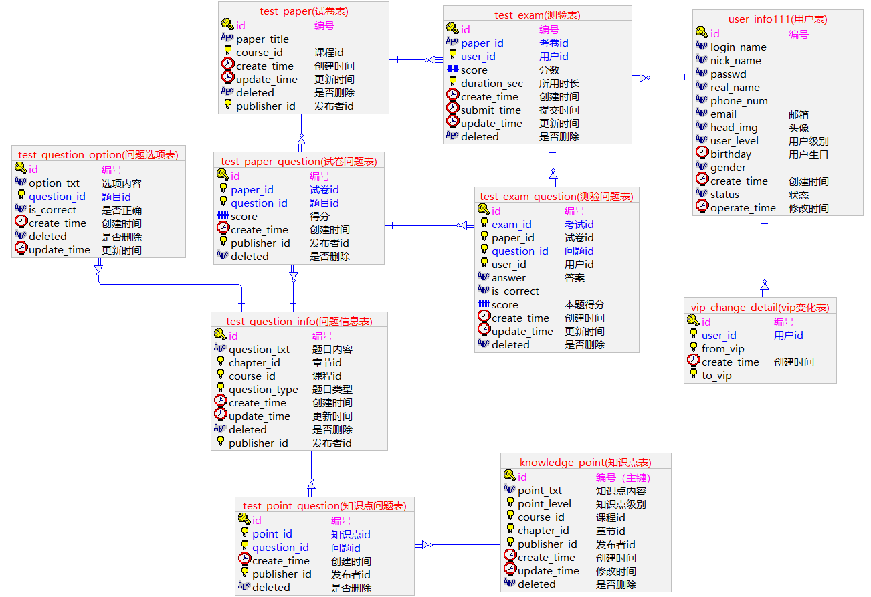

这种建模方法的出发点是整合数据，其目的是将整个企业的数据进行组合和合并，并进行规范处理，减少数据冗余性，保证数据的一致性。这种模型并不适合直接用于分析统计。

2.2.2 维度模型

数据仓库领域的另一位大师——Ralph Kimball倡导的建模方法为维度建模。维度模型将复杂的业务通过事实和维度两个概念进行呈现。事实通常对应业务过程，而维度通常对应业务过程发生时所处的环境。

注：业务过程可以概括为一个个不可拆分的行为事件，例如在线教育交易中的下单，付款，加购等，都是业务过程。

下图为一个典型的维度模型，其中位于中心的SalesOrder为事实表，其中保存的是下单这个业务过程的所有记录。位于周围每张表都是维度表，包括Date（日期），Customer（顾客），Product（产品），Location（地区）等，这些维度表就组成了每个订单发生时所处的环境，即何人、何时、在何地下单了何种产品。从图中可以看出，模型相对清晰、简洁。

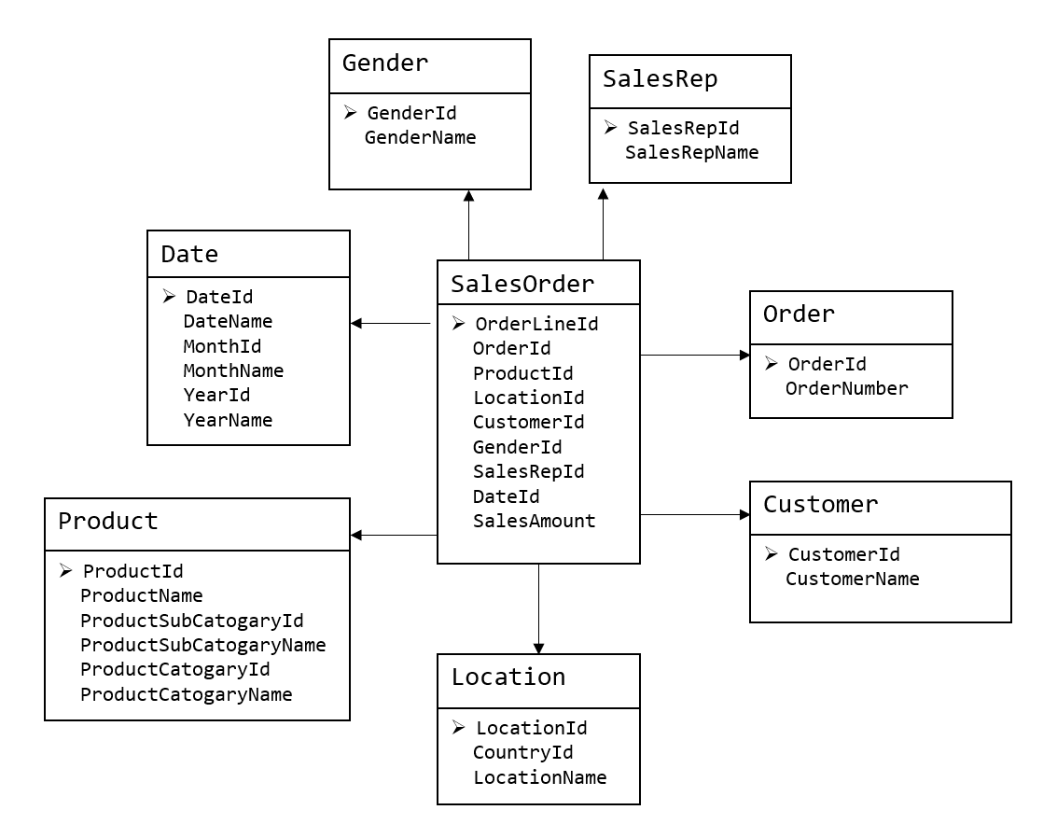

维度建模以数据分析作为出发点，为数据分析服务，因此它关注的重点的用户如何更快的完成需求分析以及如何实现较好的大规模复杂查询的响应性能。

第3章 维度建模理论之事实表

3.1 事实表概述

事实表作为数据仓库维度建模的核心，紧紧围绕着业务过程来设计。其包含与该业务过程有关的维度引用（维度表外键）以及该业务过程的度量（通常是可累加的数字类型字段）。

3.1.1 事实表特点

事实表通常比较“细长”，即列较少，但行较多，且行的增速快。

3.1.2 事实表分类

事实表有三种类型：分别是事务事实表、周期快照事实表和累积快照事实表，每种事实表都具有不同的特点和适用场景，下面逐个介绍。

3.2 事务型事实表

3.2.1 概述

事务事实表用来记录各业务过程，它保存的是各业务过程的原子操作事件，即最细粒度的操作事件。粒度是指事实表中一行数据所表达的业务细节程度。

事务型事实表可用于分析与各业务过程相关的各项统计指标，由于其保存了最细粒度的记录，可以提供最大限度的灵活性，可以支持无法预期的各种细节层次的统计需求。

3.2.2 设计流程

设计事务事实表时一般可遵循以下四个步骤：

选择业务过程→声明粒度→确认维度→确认事实

1）选择业务过程

在业务系统中，挑选我们感兴趣的业务过程，业务过程可以概括为一个个不可拆分的行为事件，例如在线教育交易中的下单，付款，加购等，都是业务过程。通常情况下，一个业务过程对应一张事务型事实表。

2）声明粒度

业务过程确定后，需要为每个业务过程声明粒度。即精确定义每张事务型事实表的每行数据表示什么，应该尽可能选择最细粒度，以此来应对各种细节程度的需求。

典型的粒度声明如下：

订单事实表中一行数据表示的是一个订单中的一门课程。

3）确定维度

确定维度具体是指，确定与每张事务型事实表相关的维度有哪些。

确定维度时应尽量多的选择与业务过程相关的环境信息。因为维度的丰富程度就决定了维度模型能够支持的指标丰富程度。

4）确定事实

此处的“事实”一词，指的是每个业务过程的度量值（通常是可累加的数字类型的值，例如：次数、个数、件数、金额等）。

经过上述四个步骤，事务型事实表就基本设计完成了。第一步选择业务过程可以确定有哪些事务型事实表，第二步可以确定每张事务型事实表的每行数据是什么，第三步可以确定每张事务型事实表的维度外键，第四步可以确定每张事务型事实表的度量值字段。

3.2.3 不足

事务型事实表可以保存所有业务过程的最细粒度的操作事件，故理论上其可以支撑与各业务过程相关的各种统计粒度的需求。但对于某些特定类型的需求，其逻辑可能会比较复杂，或者效率会比较低下。例如：

1）存量型指标

例如购物车存量，账户余额等。此处以在线教育中的加购业务为例，加购业务包含的业务过程主要包括加购物车和减购物车，两个业务过程各自对应一张事务型事实表，一张存储所有加购物车的原子操作事件，另一张存储所有减购物车的原子操作事件。

假定现有一个需求，要求统计截至当日的各用户各科目的购物车存量。由于加购物车和减购物车操作均会影响到购物车存量，故需要对两张事务型事实表进行聚合，且需要区分两者对购物车存量的影响（加或减），另外需要对两张表的全表数据聚合才能得到统计结果。

可以看到，不论是从逻辑上还是效率上考虑，这都不是一个好的方案。

2）多事务关联统计

例如，现需要统计最近30天，用户下单到支付的时间间隔的平均值。统计思路应该是找到下单事务事实表和支付事务事实表，过滤出最近30天的记录，然后按照订单id对两张事实表进行关联，之后用支付时间减去下单时间，然后再求平均值。

逻辑上虽然并不复杂，但是其效率较低，因为下单事务事实表和支付事务事实表均为大表，大表join大表的操作应尽量避免。

可以看到，在上述两种场景下事务型事实表的表现并不理想。下面要介绍的另外两种类型的事实表就是为了弥补事务型事实表的不足的。

3.3 周期型快照事实表

3.3.1 概述

周期快照事实表以具有规律性的、可预见的时间间隔来记录事实，主要用于分析一些存量型（例如购物车存量，账户余额）或者状态型（空气温度，行驶速度）指标。

对于购物车存量、账户余额这些存量型指标，业务系统中通常就会计算并保存最新结果，所以定期同步一份全量数据到数据仓库，构建周期型快照事实表，就能轻松应对此类统计需求，而无需再对事务型事实表中大量的历史记录进行聚合了。

对于空气温度、行驶速度这些状态型指标，由于它们的值往往是连续的，我们无法捕获其变动的原子事务操作，所以无法使用事务型事实表统计此类需求。而只能定期对其进行采样，构建周期型快照事实表。

3.4 累积型快照事实表

3.4.1 概述

累积型快照事实表是基于一个业务流程中的多个关键业务过程联合处理而构建的事实表，如交易流程中的试听、下单、支付等业务过程。

累积型快照事实表通常具有多个日期字段，每个日期对应业务流程中的一个关键业务过程（里程碑）。

|  |  |  |  |  |  |  |
| --- | --- | --- | --- | --- | --- | --- |
| 课程id | 用户id | 试听日期 | 下单日期 | 支付日期 | 订单分摊金额 | 支付分摊金额 |
| 1001 | 1234 | 2022-02-19 | 2022-02-20 | 2022-02-21 | 1000 | 1000 |

累积型快照事实表主要用于分析业务过程（里程碑）之间的时间间隔等需求。例如前文提到的用户下单到支付的平均时间间隔，使用累积型快照事实表进行统计，就能避免两个事务事实表的关联操作，从而变得十分简单高效。

第4章 维度建模理论之维度表

4.1 维度表概述

维度表是维度建模的基础和灵魂。前文提到，事实表紧紧围绕业务过程进行设计，而维度表则围绕业务过程所处的环境进行设计。维度表主要包含一个主键和各种维度字段，维度字段称为维度属性。

4.2 维度表设计步骤

1）确定维度（表）

在设计事实表时，已经确定了与每个事实表相关的维度，理论上每个相关维度均需对应一张维度表。需要注意到，可能存在多个事实表与同一个维度都相关的情况，这种情况需保证维度的唯一性，即只创建一张维度表。另外，如果某些维度表的维度属性很少，例如只有一个**名称，则可不创建该维度表，而把该表的维度属性直接增加到与之相关的事实表中，这个操作称为维度退化。

2）确定主维表和相关维表

此处的主维表和相关维表均指业务系统中与某维度相关的表。例如业务系统中与课程相关的表有course_info，chapter_info，base_subject_info，base_category_info，video_info等，其中course_info就称为课程维度的主维表，其余表称为课程维度的相关维表。维度表的粒度通常与主维表相同。

3）确定维度属性

确定维度属性即确定维度表字段。维度属性主要来自于业务系统中与该维度对应的主维表和相关维表。维度属性可直接从主维表或相关维表中选择，也可通过进一步加工得到。

确定维度属性时，需要遵循以下要求：

（1）尽可能生成丰富的维度属性

维度属性是后续做分析统计时的查询约束条件、分组字段的基本来源，是数据易用性的关键。维度属性的丰富程度直接影响到数据模型能够支持的指标的丰富程度。

（2）尽量不使用编码，而使用明确的文字说明，一般可以编码和文字共存。

（3）尽量沉淀出通用的维度属性

有些维度属性的获取需要进行比较复杂的逻辑处理，例如需要通过多个字段拼接得到。为避免后续每次使用时的重复处理，可将这些维度属性沉淀到维度表中。

4.3 维度设计要点

4.3.1 规范化与反规范化

规范化是指使用一系列范式设计数据库的过程，其目的是减少数据冗余，增强数据的一致性。通常情况下，规范化之后，一张表的字段会拆分到多张表。

反规范化是指将多张表的数据冗余到一张表，其目的是减少join操作，提高查询性能。

在设计维度表时，如果对其进行规范化，得到的维度模型称为雪花模型，如果对其进行反规范化，得到的模型称为星型模型。



数据仓库系统的主要目的是用于数据分析和统计，所以是否方便用户进行统计分析决定了模型的优劣。采用雪花模型，用户在统计分析的过程中需要大量的关联操作，使用复杂度高，同时查询性能很差，而采用星型模型，则方便、易用且性能好。所以出于易用性和性能的考虑，维度表一般是很不规范化的。

第5章 数据仓库环境准备

5.1 数据仓库运行环境

5.1.1 Hive环境搭建

5.1.1.1 Hive安装部署

**1）把hive-3.1.3.tar.gz上传到linux的/opt/software目录下**

**2）解压hive-3.1.3.tar.gz到/opt/module/目录下面**

[atguigu@hadoop102 software]$ tar -zxvf /opt/software/hive-3.1.3.tar.gz -C /opt/module/

**3）修改hive-3.1.3-bin.tar.gz的名称为hive**

[atguigu@hadoop102 software]$ mv /opt/module/apache-hive-3.1.3-bin/ /opt/module/hive

**4）修改/etc/profile.d/my_env.sh，添加环境变量**

[atguigu@hadoop102 software]$ sudo vim /etc/profile.d/my_env.sh

添加内容

#HIVE_HOME

export HIVE_HOME=/opt/module/hive

export PATH=$PATH:$HIVE_HOME/bin

重启Xshell对话框或者source一下 /etc/profile.d/my_env.sh文件，使环境变量生效。

[atguigu@hadoop102 software]$ source /etc/profile.d/my_env.sh

**5）解决日志Jar包冲突，进入/opt/module/hive/lib目录**

[atguigu@hadoop102 lib]$ mv log4j-slf4j-impl-2.17.1.jar log4j-slf4j-impl-2.17.1.jar.bak

5.1.1.2 Hive元数据配置到MySQL

**1）登陆MySQL**

将MySQL的JDBC驱动拷贝到Hive的lib目录下。

[atguigu@hadoop102 lib]$ cp /opt/software/mysql/mysql-connector-j-8.0.31.jar /opt/module/hive/lib/

**2）配置Metastore到MySQL**

在$HIVE_HOME/conf目录下新建hive-site.xml文件。

[atguigu@hadoop102 conf]$ vim hive-site.xml

添加如下内容。

<?xml version="1.0"?>

<?xml-stylesheet type="text/xsl" href="configuration.xsl"?>

<configuration>

<!--配置Hive保存元数据信息所需的 MySQL URL地址-->

<property>

<name>javax.jdo.option.ConnectionURL</name>

<value>jdbc:mysql://hadoop102:3306/metastore?useSSL=false&amp;useUnicode=true&amp;characterEncoding=UTF-8&amp;allowPublicKeyRetrieval=true</value>

</property>

<!--配置Hive连接MySQL的驱动全类名-->

<property>

<name>javax.jdo.option.ConnectionDriverName</name>

<value>com.mysql.cj.jdbc.Driver</value>

</property>

<!--配置Hive连接MySQL的用户名 -->

<property>

<name>javax.jdo.option.ConnectionUserName</name>

<value>root</value>

</property>

<!--配置Hive连接MySQL的密码 -->

<property>

<name>javax.jdo.option.ConnectionPassword</name>

<value>000000</value>

</property>

<property>

<name>hive.metastore.warehouse.dir</name>

<value>/user/hive/warehouse</value>

</property>

<property>

<name>hive.metastore.schema.verification</name>

<value>false</value>

</property>

<property>

<name>hive.metastore.event.db.notification.api.auth</name>

<value>false</value>

</property>

</configuration>

5.1.1.3 启动Hive

**1）初始化元数据库**

登陆MySQL

[atguigu@hadoop102 conf]$ mysql -uroot -p000000

新建Hive元数据库

mysql> create database metastore;

初始化Hive元数据库

[atguigu@hadoop102 conf]$ schematool -initSchema -dbType mysql -verbose

修改元数据库字符集

Hive元数据库的字符集默认为Latin1，由于其不支持中文字符，所以建表语句中如果包含中文注释，会出现乱码现象。如需解决乱码问题，须做以下修改。

修改Hive元数据库中存储注释的字段的字符集为utf-8。

字段注释

mysql> alter table metastore.COLUMNS_V2 modify column COMMENT varchar(256) character set utf8mb4;

表注释

mysql> alter table metastore.TABLE_PARAMS modify column PARAM_VALUE mediumtext character set utf8mb4;

退出mysql

mysql> quit;

**2）启动Hive客户端**

启动Hive客户端

[atguigu@hadoop102 hive]$ hive

查看一下数据库

hive (default)> show databases;

OK

database_name

default

Time taken: 0.955 seconds, Fetched: 1 row(s)

5.1.2 Hive引擎简介

5.1.2.1 Hive引擎简介

Hive引擎包括：默认MR、tez、spark

Hive on Spark：Hive既作为存储元数据又负责SQL的解析优化，语法是HQL语法，执行引擎变成了Spark，Spark负责采用RDD执行。

Spark on Hive : Hive只作为存储元数据，Spark负责SQL解析优化，语法是Spark SQL语法，Spark负责采用RDD执行。

5.1.2.2 Hive on Spark配置

（1）兼容性说明

注意：官网下载的Hive3.1.3和Spark3.3.1默认是不兼容的。因为Hive3.1.3支持的Spark版本是2.3.0，所以需要我们重新编译Hive3.1.3版本。

编译步骤：官网下载Hive3.1.3源码，修改pom文件中引用的Spark版本为3.3.1，如果编译通过，直接打包获取jar包。如果报错，就根据提示，修改相关方法，直到不报错，打包获取jar包。

（2）在Hive所在节点部署Spark纯净版

①Spark官网下载jar包地址：

<http://spark.apache.org/downloads.html>

②上传并解压解压spark-3.3.1-bin-without-hadoop.tgz

[atguigu@hadoop102 software]$ tar -zxvf spark-3.3.1-bin-without-hadoop.tgz -C /opt/module/

[atguigu@hadoop102 software]$ mv /opt/module/spark-3.3.1-bin-without-hadoop /opt/module/spark

③修改spark-env.sh配置文件

修改文件名。

[atguigu@hadoop102 software]$ mv /opt/module/spark/conf/spark-env.sh.template /opt/module/spark/conf/spark-env.sh

编辑文件

[atguigu@hadoop102 software]$ vim /opt/module/spark/conf/spark-env.sh

增加如下内容。

export SPARK_DIST_CLASSPATH=$(hadoop classpath)

（3）配置SPARK_HOME环境变量

[atguigu@hadoop102 software]$ sudo vim /etc/profile.d/my_env.sh

添加如下内容。

# SPARK_HOME

export SPARK_HOME=/opt/module/spark

export PATH=$PATH:$SPARK_HOME/bin

source 使其生效。

[atguigu@hadoop102 software]$ source /etc/profile.d/my_env.sh

**（4）在hive中创建spark配置文件**

[atguigu@hadoop102 software]$ vim /opt/module/hive/conf/spark-defaults.conf

添加如下内容（在执行任务时，会根据如下参数执行）。

spark.master yarn

spark.eventLog.enabled true

spark.eventLog.dir hdfs://mycluster/spark-history

spark.executor.memory 1g

spark.driver.memory 1g

在HDFS创建如下路径，用于存储历史日志。

[atguigu@hadoop102 software]$ hadoop fs -mkdir /spark-history

**（5）向HDFS上传Spark纯净版jar包**

说明1：采用Spark纯净版jar包，不包含hadoop和hive相关依赖，能避免依赖冲突。

说明2：Hive任务最终由Spark来执行，Spark任务资源分配由Yarn来调度，该任务有可能被分配到集群的任何一个节点。所以需要将Spark的依赖上传到HDFS集群路径，这样集群中任何一个节点都能获取到。

[atguigu@hadoop102 software]$ hadoop fs -mkdir /spark-jars

[atguigu@hadoop102 software]$ hadoop fs -put /opt/module/spark/jars/* /spark-jars

**（6）修改hive-site.xml文件**

[atguigu@hadoop102 ~]$ vim /opt/module/hive/conf/hive-site.xml

添加如下内容。

**<!--Spark依赖位置（注意：端口号8020必须和namenode的端口号一致）-->**

<property>

<name>spark.yarn.jars</name>

<value>hdfs://mycluster/spark-jars/*</value>

</property>

**<!--Hive执行引擎-->**

<property>

<name>hive.execution.engine</name>

<value>spark</value>

</property>

**3）Hive on Spark测试**

（1）启动hive客户端

[atguigu@hadoop102 hive]$ hive

（2）创建一张测试表

hive (default)> create table student(id int, name string);

（3）通过insert测试效果

hive (default)> insert into table student values(1,'abc');

若结果如下，则说明配置成功。

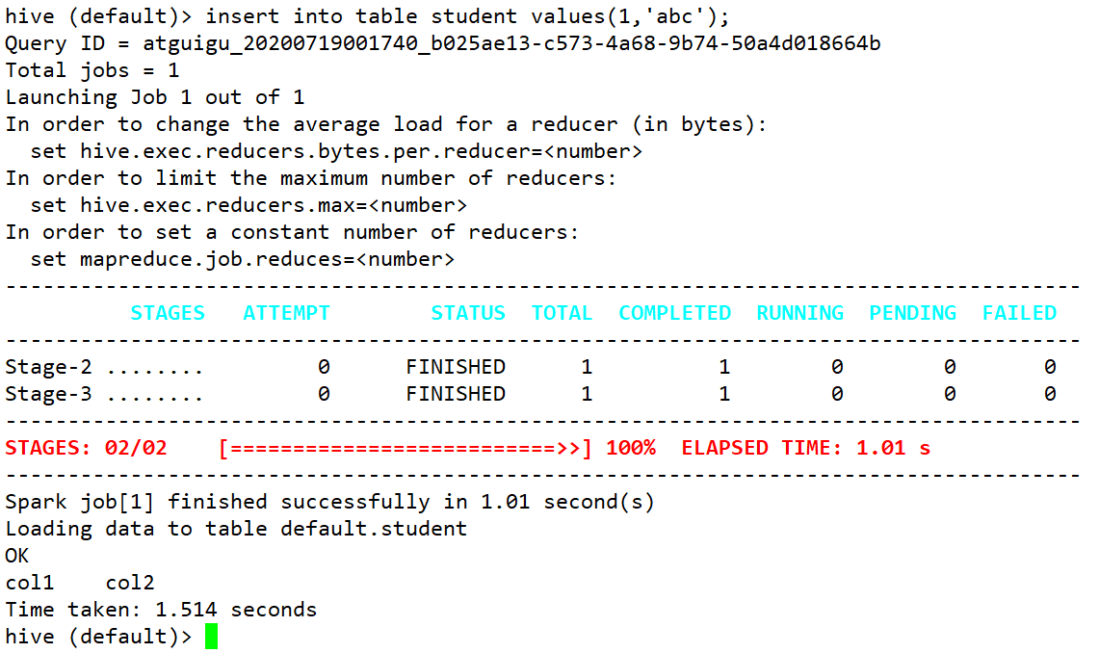

5.1.3 Yarn环境配置

容量调度器对每个资源队列中同时运行的Application Master占用的资源进行了限制，该限制通过yarn.scheduler.capacity.maximum-am-resource-percent参数实现，其默认值是0.1，表示每个资源队列上Application Master最多可使用的资源为该队列总资源的10%，目的是防止大部分资源都被Application Master占用，而导致Map/Reduce Task无法执行。

生产环境该参数可使用默认值。但学习环境，集群资源总数很少，如果只分配10%的资源给Application Master，则可能出现，同一时刻只能运行一个Job的情况，因为一个Application Master使用的资源就可能已经达到10%的上限了。故此处可将该值适当调大。

（1）在hadoop102的/opt/module/hadoop/etc/hadoop/capacity-scheduler.xml文件中修改如下参数值

[atguigu@hadoop102 hadoop]$ vim capacity-scheduler.xml

<property>

<name>yarn.scheduler.capacity.maximum-am-resource-percent</name>

<value>0.8</value>

</property>

（2）分发capacity-scheduler.xml配置文件

[atguigu@hadoop102 hadoop]$ xsync capacity-scheduler.xml

（3）关闭正在运行的任务，重新启动yarn集群

[atguigu@hadoop103 hadoop]$ stop-yarn.sh

[atguigu@hadoop103 hadoop]$ start-yarn.sh

5.2 数据仓库开发环境

数仓开发工具可选用DBeaver或者DataGrip。两者都需要用到JDBC协议连接到Hive，故需要启动HiveServer2。

5.2.1 启动HiveServer2

[atguigu@hadoop102 hive]$ hiveserver2

5.2.2 配置DataGrip连接

（1）创建连接

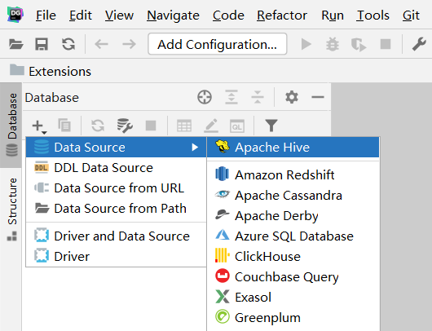

（2）配置连接属性

所有属性配置，和Hive的beeline客户端配置一致即可。初次使用，配置过程会提示缺少JDBC驱动，按照提示下载即可。

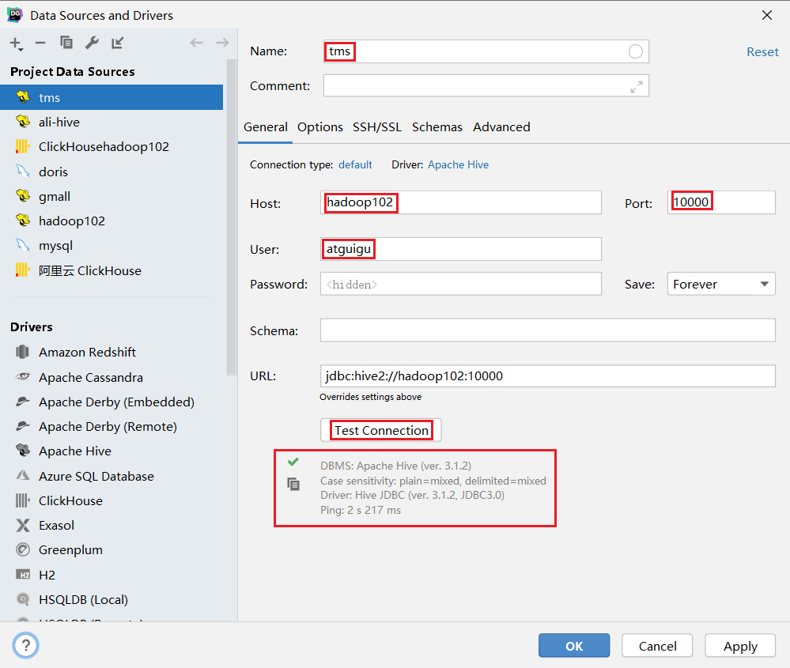

5.2.3 测试使用

创建数据库car_data，并观察是否创建成功。

（1）创建数据库

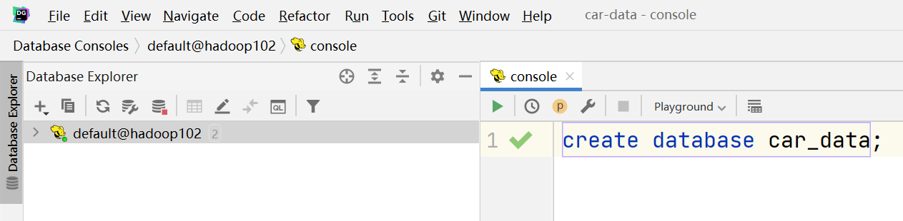（2）查看数据库

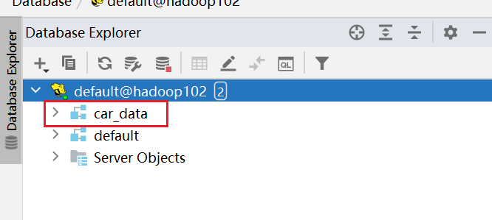

（3）修改连接，指明连接数据库

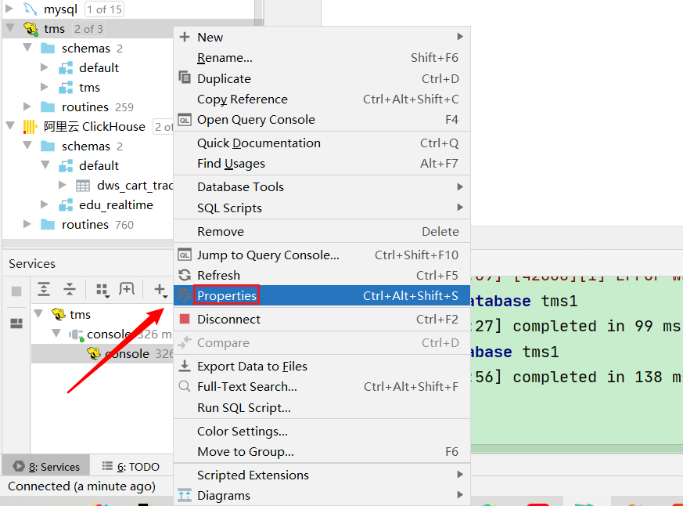

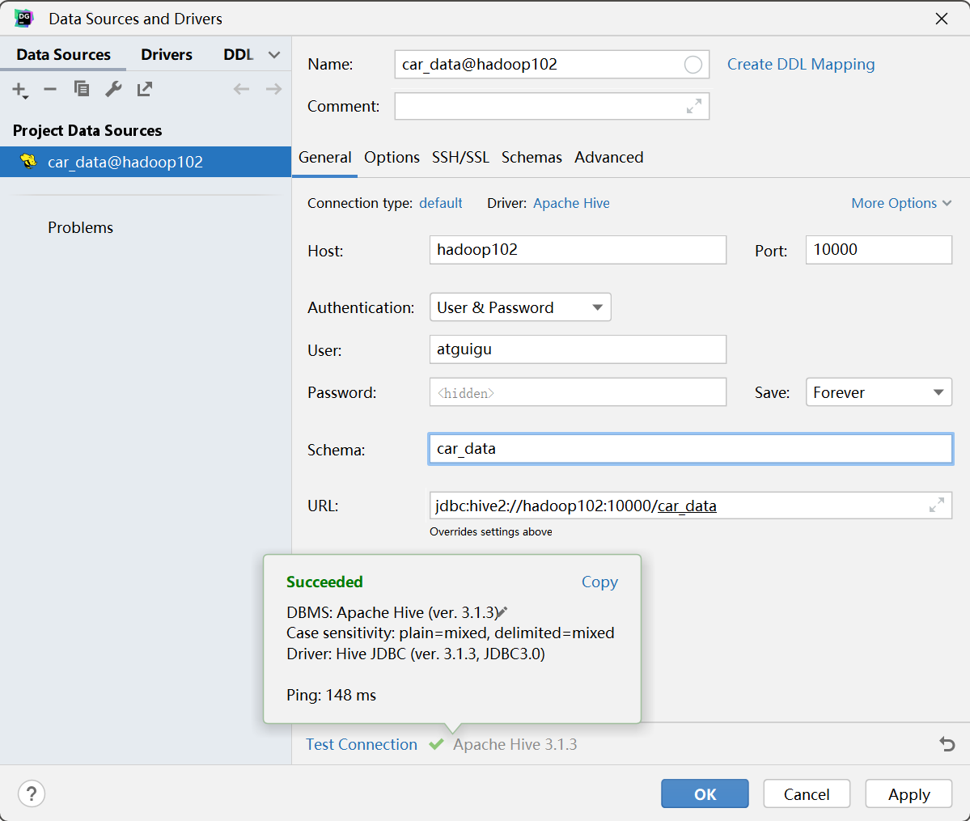

（4）选择当前数据库为tms

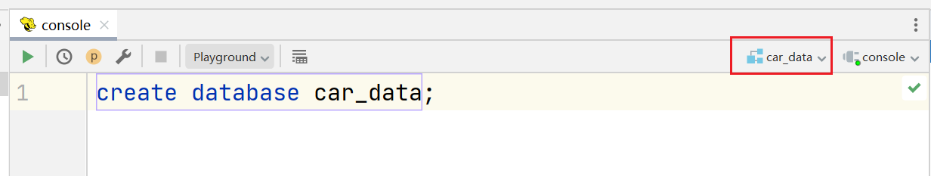

5.3 模拟数据准备

本项目只有一张汽车维度表数据和汽车的行驶日志数据。由于采集项目通常比数仓项目先上线，所有在具体的数据导入时，往往会存在一定量的历史数据。我们假设本数仓创建于2023-05-02，此时已经有2日的历史行驶数据需要处理。

注：在执行以下操作之前，先将HDFS上/origin_data路径下之前的数据删除。

日志采集需要启动如下组件：HDFS, Kafka, Flume

# 启动Zookeeper

[atguigu@hadoop102 ~]$ zk.sh start

# 启动HDFS

[atguigu@hadoop102 ~]$ start-dfs.sh

# 启动Kafka

[atguigu@hadoop102 ~]$ kf.sh start

# 启动Flume

[atguigu@hadoop102 ~]$ f1.sh start

[atguigu@hadoop102 ~]$ f2.sh start

日志采集通道回顾：





执行日志生成命令：

[atguigu@hadoop102 ~]$ cd /opt/module/car-data/

[atguigu@hadoop102 car-data]$ java -jar \

car-data-1.0-jar-with-dependencies.jar \

-c 1 \

-d 2023-05-02 \

-n root \

-p 000000 \

-u jdbc:mysql://hadoop102:3306/car_data

维度数据需要执行Datax。

[atguigu@hadoop102 ~]$ mysql_to_hdfs.sh 2023-05-02

查看HDFS有没有相应数据：

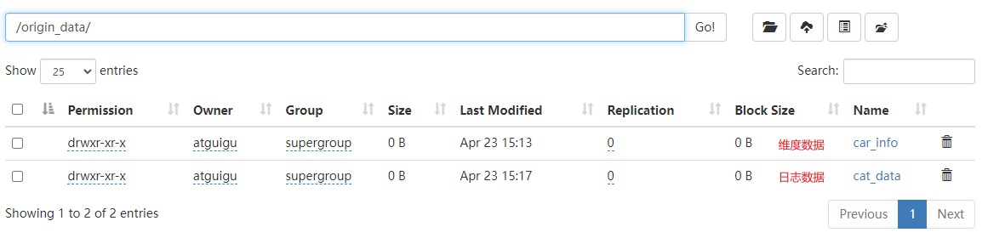

5.4 Hive 常见问题及解决方式

5.4.1 DataGrip 刷新连接时 hiveserver2 后台报错

（1）报错信息如下

FAILED: ParseException line 1:5 cannot recognize input near 'show' 'indexes' 'on' in ddl statement

原因：我们使用的是Hive-3.1.3，早期版本的Hive有索引功能，当前版本已移除， DataGrip刷新连接时会扫描索引，而 Hive 没有，就会报错。

（2）报错信息如下

FAILED: Execution Error, return code 1 from org.apache.hadoop.hive.ql.exec.DDLTask. Current user : atguigu is not allowed to list roles. User has to belong to ADMIN role and have it as current role, for this action.

FAILED: Execution Error, return code 1 from org.apache.hadoop.hive.ql.exec.DDLTask. Current user : atguigu is not allowed get principals in a role. User has to belong to ADMIN role and have it as current role, for this action. Otherwise, grantor need to have ADMIN OPTION on role being granted and have it as a current role for this action.

DataGrip 连接 hiveserver2 时会做权限认证，但本项目中我们没有对 Hive 的权限管理进行配置，因而报错。

上述两个问题都是 DataGrip 导致的，并非 Hive 环境的问题，不影响使用

5.4.2 OOM 报错

Hive 默认堆内存只有 256M，如果 hiveserver2 后台频繁出现 OutOfMemoryError，可以调大堆内存。

在 Hive 家目录的 conf 目录下复制一份模板文件hive-env.sh.template

[atguigu@hadoop102 conf]$ cd $HIVE_HOME/conf

[atguigu@hadoop102 conf]$ cp hive-env.sh.template hive-env.sh

修改 hive-env.sh，将 Hive 堆内存改为 1024M，如下

export HADOOP_HEAPSIZE=1024

可根据实际使用情况适当调整堆内存。

5.4.3 DataGrip ODS 层部分表字段显示异常

建表字段中有如下语句的表字段无法显示

ROW FORMAT SERDE 'org.apache.hadoop.hive.serde2.JsonSerDe'

上述语句指定了 Hive 表的序列化器和反序列化器 SERDE（serialization 和 deserialization 的合并缩写），用于解析 JSON 格式的文件。上述 SERDE 是由第三方提供的，在 hive-site.xml 中添加如下配置即可解决

<property>

<name>metastore.storage.schema.reader.impl</name>

<value>org.apache.hadoop.hive.metastore.SerDeStorageSchemaReader</value>

</property>

1. 数仓开发之ODS层

优秀可靠的数仓体系，需要良好的数据分层结构。合理的分层，能够使数据体系更加清晰，使复杂问题得以简化。以下是该项目的分层规划。



ODS层的设计要点如下：

（1）ODS层的表结构设计依托于从业务系统同步过来的数据结构。

（2）ODS层要保存全部历史数据，故其压缩格式应选择压缩比较高的，此处选择gzip。

（3）ODS层表名的命名规范为：ods_表名_单分区增量全量标识（inc/full）。

6.1 整车日志表（增量日志表）

create external table ods_car_data_inc

(

`vin` string comment '汽车唯一ID',

`car_status` int comment '车辆状态',

`charge_status` int comment '充电状态',

`execution_mode` int comment '运行模式',

`velocity` int comment '车速',

`mileage` int comment '里程',

`voltage` int comment '总电压',

`electric_current` int comment '总电流',

`soc` int comment 'SOC',

`dc_status` int comment 'DC-DC状态',

`gear` int comment '挡位',

`insulation_resistance` int comment '绝缘电阻',

`motor_count` int comment '驱动电机个数',

`motor_list` array<struct<`id` :int, `status` :int, `rev` :int, `torque` :int,

`controller_temperature` :int, `temperature` :int,

`voltage`

:int, `electric_current` :int>> comment '驱动电机列表',

`fuel_cell_voltage` int comment '燃料电池电压',

`fuel_cell_current` int comment '燃料电池电流',

`fuel_cell_consume_rate` int comment '燃料消耗率',

`fuel_cell_temperature_probe_count` int comment '燃料电池温度探针总数',

`fuel_cell_temperature` int comment '燃料电池温度值',

`fuel_cell_max_temperature` int comment '氢系统中最高温度',

`fuel_cell_max_temperature_probe_id` int comment '氢系统中最高温度探针号',

`fuel_cell_max_hydrogen_consistency` int comment '氢气最高浓度',

`fuel_cell_max_hydrogen_consistency_probe_id` int comment '氢气最高浓度传感器代号',

`fuel_cell_max_hydrogen_pressure` int comment '氢气最高压力',

`fuel_cell_max_hydrogen_pressure_probe_id` int comment '氢气最高压力传感器代号',

`fuel_cell_dc_status` int comment '高压DC-DC状态',

`engine_status` int comment '发动机状态',

`crankshaft_speed` int comment '曲轴转速',

`fuel_consume_rate` int comment '燃料消耗率',

`max_voltage_battery_pack_id` int comment '最高电压电池子系统号',

`max_voltage_battery_id` int comment '最高电压电池单体代号',

`max_voltage` int comment '电池单体电压最高值',

`min_temperature_subsystem_id` int comment '最低电压电池子系统号',

`min_voltage_battery_id` int comment '最低电压电池单体代号',

`min_voltage` int comment '电池单体电压最低值',

`max_temperature_subsystem_id` int comment '最高温度子系统号',

`max_temperature_probe_id` int comment '最高温度探针号',

`max_temperature` int comment '最高温度值',

`min_voltage_battery_pack_id` int comment '最低温度子系统号',

`min_temperature_probe_id` int comment '最低温度探针号',

`min_temperature` int comment '最低温度值',

`alarm_level` int comment '报警级别',

`alarm_sign` int comment '通用报警标志',

`custom_battery_alarm_count` int comment '可充电储能装置故障总数N1',

`custom_battery_alarm_list` array<int> comment '可充电储能装置故障代码列表',

`custom_motor_alarm_count` int comment '驱动电机故障总数N2',

`custom_motor_alarm_list` array<int> comment '驱动电机故障代码列表',

`custom_engine_alarm_count` int comment '发动机故障总数N3',

`custom_engine_alarm_list` array<int> comment '发动机故障代码列表',

`other_alarm_count` int comment '其他故障总数N4',

`other_alarm_list` array<int> comment '其他故障代码列表',

`battery_count` int comment '单体电池总数',

`battery_pack_count` int comment '单体电池包总数',

`battery_voltages` array<int> comment '单体电池电压值列表',

`battery_temperature_probe_count` int comment '单体电池温度探针总数',

`battery_pack_temperature_count` int comment '单体电池包总数',

`battery_temperatures` array<int> comment '单体电池温度值列表',

\`timestamp\` bigint comment '日志采集时间'

)

comment '整车日志表'

partitioned by (`dt` string comment '统计日期')

ROW FORMAT SERDE 'org.apache.hadoop.hive.serde2.JsonSerDe'

location '/warehouse/car_data/ods/ods_car_data_inc';

6.2 汽车信息表（全量表）

drop table if exists ods_car_info_full;

create external table ods_car_info_full

(

`id` string comment '车辆唯一编码',

`type_id` string comment '车型ID',

`type` string comment '车型',

`sale_type` string comment '销售车型',

`trademark` string comment '品牌',

`company` string comment '厂商',

`seating_capacity` int comment '准载人数',

`power_type` string comment '车辆动力类型',

`charge_type` string comment '车辆支持充电类型',

`category` string comment '车辆分类',

`weight_kg` int comment '总质量（kg）',

`warranty` string comment '整车质保期（年/万公里）'

) comment '整车信息表'

partitioned by (`dt` string comment '统计日期')

row format delimited fields terminated by '\t'

location '/warehouse/car_data/ods/ods_car_info_full';

6.3 数据装载脚本

在hadoop102的/home/atguigu/bin目录下创建hdfs_to_ods.sh

[atguigu@hadoop102 bin]$ vim hdfs_to_ods.sh

编写如下内容

#!/bin/bash

APP='car_data'

# 判断第二个参数是否填写 如果填写使用作为日期 如果没有填写 默认使用昨天作为日期

if [ -n "$2" ]; then

#statements

do_date=$2

else

do_date=`date -d '-1 day' +%F`

fi

case "$1" in

"ods_car_data_inc" )

hive -e "load data inpath '/origin_data/car_data_full/$do_date' into table $APP.ods_car_data_inc partition (dt='$do_date');"

;;

"ods_car_info_full" )

hive -e "load data inpath '/origin_data/car_info_full/$do_date' into table $APP.ods_car_info_full partition (dt='$do_date');"

;;

"all" )

hive -e "load data inpath '/origin_data/car_data_full/$do_date' into table $APP.ods_car_data_inc partition (dt='$do_date');

load data inpath '/origin_data/car_info_full/$do_date' into table $APP.ods_car_info_full partition (dt='$do_date');"

;;

esac

赋予脚本执行权限

[atguigu@hadoop102 bin]$ chmod +x hdfs_to_ods.sh

脚本用法

[atguigu@hadoop102 bin]$ hdfs_to_ods.sh all 2023-05-02

第7章 数仓开发之DIM层

DIM层设计要点：

（1）DIM层的设计依据是维度建模理论，该层存储维度模型的维度表。

（2）DIM层的数据存储格式为orc列式存储+snappy压缩。

（3）DIM层表名的命名规范为dim_表名_全量表或者拉链表标识（full/zip）

7.1 车辆信息维度表

7.1.1 建表语句

drop table if exists dim_car_info_full;

create external table dim_car_info_full

(

`id` string comment '车辆唯一编码',

`type_id` string comment '车型ID',

`type` string comment '车型',

`sale_type` string comment '销售车型',

`trademark` string comment '品牌',

`company` string comment '厂商',

`seating_capacity` int comment '准载人数',

`power_type` string comment '车辆动力类型',

`charge_type` string comment '车辆支持充电类型',

`category` string comment '车辆分类',

`weight_kg` int comment '总质量（kg）',

`warranty` string comment '整车质保期（年/万公里）'

) comment '车辆信息维度表'

partitioned by (`dt` string comment '统计日期')

stored as orc

location '/warehouse/car_data/dim/dim_car_info_full'

tblproperties ('orc.compress' = 'snappy');

7.1.2 数据装载

insert overwrite table car_data.dim_car_info_full partition (dt = '2023-05-02')

select id,

type_id,

type,

sale_type,

trademark,

company,

seating_capacity,

power_type,

charge_type,

category,

weight_kg,

warranty

from car_data.ods_car_info_full o

where o.dt = '2023-05-02';

7.2 日志编码维度表

7.2.1 建表语句

drop table if exists dim_code_full;

create external table dim_code_full

(

`type` string comment '编码类型',

`code_id` string comment '编码ID',

`code_name` string comment '编码名称'

) comment '日志编码维度表'

stored as orc

location '/warehouse/car_data/dim/dim_code_full'

tblproperties ('orc.compress' = 'snappy');

7.2.2 数据装载

因为dim层的表格具有压缩和存储格式，所有不能直接上传文件到hive的表格路径，需要先上传文件car_data_code.txt到临时表中。

创建临时表

drop table if exists tmp_code_full;

create external table tmp_code_full

(

`type` string comment '编码类型',

`code_id` string comment '编码ID',

`code_name` string comment '编码名称'

) comment '日志编码维度表'

row format delimited

fields terminated by '\t'

location '/warehouse/car_data/tmp/tmp_code_full';

之后把car_data_code.txt文件放入到临时表的路径中。

insert into table dim_code_full select * from tmp_code_full;

7.3 数据装载脚本

在hadoop102的/home/atguigu/bin目录下创建ods_to_dim.sh

[atguigu@hadoop102 bin]$ vim ods_to_dim.sh

编写如下内容

#!/bin/bash

APP='car_data'

if [ -n "$2" ]; then

do_date=$2

else

do_date=$(date -d '-1 day' +%F)

fi

dim_car_info_full="

insert overwrite table ${APP}.dim_car_info_full partition (dt = '$do_date')

select id,

type_id,

type,

sale_type,

trademark,

company,

seating_capacity,

power_type,

charge_type,

category,

weight_kg,

warranty

from ${APP}.ods_car_info_full o

where o.dt = '$do_date';

"

case $1 in

'dim_car_info_full')

hive -e "${dim_car_info_full}"

;;

"all")

hive -e "${dim_car_info_full}"

;;

esac

赋予脚本执行权限

[atguigu@hadoop102 bin]$ chmod +x ods_to_dim.sh

脚本用法

[atguigu@hadoop102 bin]$ ods_to_dim.sh all 2023-05-01

第8章 数仓开发之DWD层

DWD层设计要点：

（1）DWD层的设计依据是维度建模理论，该层存储维度模型的事实表。

（2）DWD层的数据存储格式为orc列式存储+snappy压缩。

（3）DWD层表名的命名规范为dwd_数据域_表名_单分区增量全量标识（inc/full）

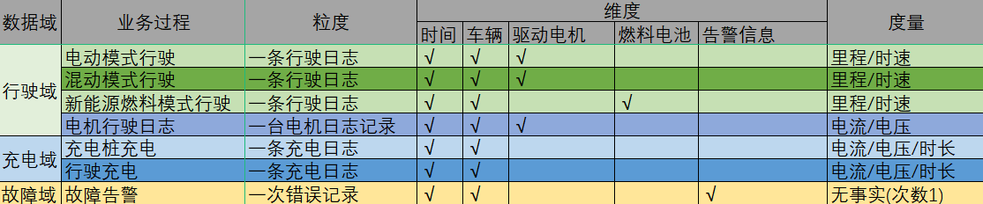

8.1 电动模式行驶日志事实表

8.1.1 建表语句

drop table if exists dwd_car_running_electricity_inc;

create external table dwd_car_running_electricity_inc

(

`vin` string comment '汽车唯一ID',

`velocity` int comment '车速',

`mileage` int comment '里程',

`voltage` int comment '总电压',

`electric_current` int comment '总电流',

`soc` int comment 'SOC',

`dc_status` int comment 'DC-DC状态',

`gear` int comment '挡位',

`insulation_resistance` int comment '绝缘电阻',

`motor_count` int comment '驱动电机个数',

`motor_list` array<struct<`id` :int, `status` :int, `rev` :int, `torque` :int,

`controller_temperature` :int, `temperature` :int,

`voltage`

:int, `electric_current` :int>> comment '驱动电机列表',

`fuel_cell_dc_status` int comment '高压DC-DC状态',

`engine_status` int comment '发动机状态',

`crankshaft_speed` int comment '曲轴转速',

`fuel_consume_rate` int comment '燃料消耗率',

`max_voltage_battery_pack_id` int comment '最高电压电池子系统号',

`max_voltage_battery_id` int comment '最高电压电池单体代号',

`max_voltage` int comment '电池单体电压最高值',

`min_temperature_subsystem_id` int comment '最低电压电池子系统号',

`min_voltage_battery_id` int comment '最低电压电池单体代号',

`min_voltage` int comment '电池单体电压最低值',

`max_temperature_subsystem_id` int comment '最高温度子系统号',

`max_temperature_probe_id` int comment '最高温度探针号',

`max_temperature` int comment '最高温度值',

`min_voltage_battery_pack_id` int comment '最低温度子系统号',

`min_temperature_probe_id` int comment '最低温度探针号',

`min_temperature` int comment '最低温度值',

`battery_count` int comment '单体电池总数',

`battery_pack_count` int comment '单体电池包总数',

`battery_voltages` array<int> comment '单体电池电压值列表',

`battery_temperature_probe_count` int comment '单体电池温度探针总数',

`battery_pack_temperature_count` int comment '单体电池包总数',

`battery_temperatures` array<int> comment '单体电池温度值列表',

`timestamp` bigint comment '日志采集时间'

)

comment '电动模式行驶日志事实表'

partitioned by (`dt` string comment '统计日期')

stored as orc

location '/warehouse/car_data/dwd/dwd_car_running_electricity_inc'

tblproperties ('orc.compress' = 'snappy');

8.1.2 数据装载

1）首日装载

set hive.exec.dynamic.partition.mode=nonstrict;

insert overwrite table car_data.dwd_car_running_electricity_inc partition(dt)

select

`vin`,

`velocity`,

`mileage`,

`voltage`,

`electric_current`,

`soc`,

`dc_status`,

`gear`,

`insulation_resistance`,

`motor_count`,

`motor_list`,

`fuel_cell_dc_status`,

`engine_status`,

`crankshaft_speed`,

`fuel_consume_rate` ,

`max_voltage_battery_pack_id`,

`max_voltage_battery_id`,

`max_voltage`,

`min_temperature_subsystem_id`,

`min_voltage_battery_id`,

`min_voltage`,

`max_temperature_subsystem_id`,

`max_temperature_probe_id`,

`max_temperature`,

`min_voltage_battery_pack_id`,

`min_temperature_probe_id`,

`min_temperature`,

`battery_count`,

`battery_pack_count`,

`battery_voltages`,

`battery_temperature_probe_count`,

`battery_pack_temperature_count`,

`battery_temperatures`,

\`timestamp\`,

`dt`

from car_data.ods_car_data_inc

where dt <='2023-05-02'

and car_status=1

and execution_mode=1;

2）每日装载

insert overwrite table car_data.dwd_car_running_electricity_inc partition(dt='2023-05-03')

select

`vin`,

`velocity`,

`mileage`,

`voltage`,

`electric_current`,

`soc`,

`dc_status`,

`gear`,

`insulation_resistance`,

`motor_count`,

`motor_list`,

`fuel_cell_dc_status`,

`engine_status`,

`crankshaft_speed`,

`fuel_consume_rate` ,

`max_voltage_battery_pack_id`,

`max_voltage_battery_id`,

`max_voltage`,

`min_temperature_subsystem_id`,

`min_voltage_battery_id`,

`min_voltage`,

`max_temperature_subsystem_id`,

`max_temperature_probe_id`,

`max_temperature`,

`min_voltage_battery_pack_id`,

`min_temperature_probe_id`,

`min_temperature`,

`battery_count`,

`battery_pack_count`,

`battery_voltages`,

`battery_temperature_probe_count`,

`battery_pack_temperature_count`,

`battery_temperatures`,

\`timestamp\`

from car_data.ods_car_data_inc

where dt='2023-05-03'

and car_status=1

and execution_mode=1;

8.2 混动模式行驶日志事实表

8.2.1 建表语句

drop table if exists dwd_car_running_hybrid_inc;

create external table dwd_car_running_hybrid_inc

(

`vin` string comment '汽车唯一ID',

`velocity` int comment '车速',

`mileage` int comment '里程',

`voltage` int comment '总电压',

`electric_current` int comment '总电流',

`soc` int comment 'SOC',

`dc_status` int comment 'DC-DC状态',

`gear` int comment '挡位',

`insulation_resistance` int comment '绝缘电阻',

`motor_count` int comment '驱动电机个数',

`motor_list` array<struct<`id` :int, `status` :int, `rev` :int, `torque` :int,

`controller_temperature` :int, `temperature` :int,

`voltage`

:int, `electric_current` :int>> comment '驱动电机列表',

`fuel_cell_dc_status` int comment '高压DC-DC状态',

`engine_status` int comment '发动机状态',

`crankshaft_speed` int comment '曲轴转速',

`fuel_consume_rate` int comment '燃料消耗率',

`max_voltage_battery_pack_id` int comment '最高电压电池子系统号',

`max_voltage_battery_id` int comment '最高电压电池单体代号',

`max_voltage` int comment '电池单体电压最高值',

`min_temperature_subsystem_id` int comment '最低电压电池子系统号',

`min_voltage_battery_id` int comment '最低电压电池单体代号',

`min_voltage` int comment '电池单体电压最低值',

`max_temperature_subsystem_id` int comment '最高温度子系统号',

`max_temperature_probe_id` int comment '最高温度探针号',

`max_temperature` int comment '最高温度值',

`min_voltage_battery_pack_id` int comment '最低温度子系统号',

`min_temperature_probe_id` int comment '最低温度探针号',

`min_temperature` int comment '最低温度值',

`battery_count` int comment '单体电池总数',

`battery_pack_count` int comment '单体电池包总数',

`battery_voltages` array<int> comment '单体电池电压值列表',

`battery_temperature_probe_count` int comment '单体电池温度探针总数',

`battery_pack_temperature_count` int comment '单体电池包总数',

`battery_temperatures` array<int> comment '单体电池温度值列表',

`timestamp` bigint comment '日志采集时间'

)

comment '混动模式行驶日志事实表'

partitioned by (`dt` string comment '统计日期')

stored as orc

location '/warehouse/car_data/dwd/dwd_car_running_hybrid_inc'

tblproperties ('orc.compress' = 'snappy');

8.2.2 数据装载

1）首日装载

set hive.exec.dynamic.partition.mode=nonstrict;

insert overwrite table car_data.dwd_car_running_hybrid_inc partition(dt)

select

`vin`,

`velocity`,

`mileage`,

`voltage`,

`electric_current`,

`soc`,

`dc_status`,

`gear`,

`insulation_resistance`,

`motor_count`,

`motor_list`,

`fuel_cell_dc_status`,

`engine_status`,

`crankshaft_speed`,

`fuel_consume_rate` ,

`max_voltage_battery_pack_id`,

`max_voltage_battery_id`,

`max_voltage`,

`min_temperature_subsystem_id`,

`min_voltage_battery_id`,

`min_voltage`,

`max_temperature_subsystem_id`,

`max_temperature_probe_id`,

`max_temperature`,

`min_voltage_battery_pack_id`,

`min_temperature_probe_id`,

`min_temperature`,

`battery_count`,

`battery_pack_count`,

`battery_voltages`,

`battery_temperature_probe_count`,

`battery_pack_temperature_count`,

`battery_temperatures`,

\`timestamp\`,

`dt`

from car_data.ods_car_data_inc

where dt <= '2023-05-02'

and car_status=1

and execution_mode=2;

2）每日装载

insert overwrite table car_data.dwd_car_running_hybrid_inc partition(dt='2023-05-03')

select

`vin`,

`velocity`,

`mileage`,

`voltage`,

`electric_current`,

`soc`,

`dc_status`,

`gear`,

`insulation_resistance`,

`motor_count`,

`motor_list`,

`fuel_cell_dc_status`,

`engine_status`,

`crankshaft_speed`,

`fuel_consume_rate` ,

`max_voltage_battery_pack_id`,

`max_voltage_battery_id`,

`max_voltage`,

`min_temperature_subsystem_id`,

`min_voltage_battery_id`,

`min_voltage`,

`max_temperature_subsystem_id`,

`max_temperature_probe_id`,

`max_temperature`,

`min_voltage_battery_pack_id`,

`min_temperature_probe_id`,

`min_temperature`,

`battery_count`,

`battery_pack_count`,

`battery_voltages`,

`battery_temperature_probe_count`,

`battery_pack_temperature_count`,

`battery_temperatures`,

\`timestamp\`

from car_data.ods_car_data_inc

where dt='2023-05-03'

and car_status=1

and execution_mode=2;

8.3 新能源燃料模式行驶日志事实表

8.3.1 建表语句

Drop table if exists dwd_car_running_fuel_inc;

create external table dwd_car_running_fuel_inc

(

`vin` string comment '汽车唯一ID',

`velocity` int comment '车速',

`mileage` int comment '里程',

`voltage` int comment '总电压',

`electric_current` int comment '总电流',

`soc` int comment 'SOC',

`dc_status` int comment 'DC-DC状态',

`gear` int comment '挡位',

`insulation_resistance` int comment '绝缘电阻',

`fuel_cell_voltage` int comment '燃料电池电压',

`fuel_cell_current` int comment '燃料电池电流',

`fuel_cell_consume_rate` int comment '燃料消耗率',

`fuel_cell_temperature_probe_count` int comment '燃料电池温度探针总数',

`fuel_cell_temperature` int comment '燃料电池温度值',

`fuel_cell_max_temperature` int comment '氢系统中最高温度',

`fuel_cell_max_temperature_probe_id` int comment '氢系统中最高温度探针号',

`fuel_cell_max_hydrogen_consistency` int comment '氢气最高浓度',

`fuel_cell_max_hydrogen_consistency_probe_id` int comment '氢气最高浓度传感器代号',

`fuel_cell_max_hydrogen_pressure` int comment '氢气最高压力',

`fuel_cell_max_hydrogen_pressure_probe_id` int comment '氢气最高压力传感器代号',

`fuel_cell_dc_status` int comment '高压DC-DC状态',

`engine_status` int comment '发动机状态',

`crankshaft_speed` int comment '曲轴转速',

`fuel_consume_rate` int comment '燃料消耗率',

`max_voltage_battery_pack_id` int comment '最高电压电池子系统号',

`max_voltage_battery_id` int comment '最高电压电池单体代号',

`max_voltage` int comment '电池单体电压最高值',

`min_temperature_subsystem_id` int comment '最低电压电池子系统号',

`min_voltage_battery_id` int comment '最低电压电池单体代号',

`min_voltage` int comment '电池单体电压最低值',

`max_temperature_subsystem_id` int comment '最高温度子系统号',

`max_temperature_probe_id` int comment '最高温度探针号',

`max_temperature` int comment '最高温度值',

`min_voltage_battery_pack_id` int comment '最低温度子系统号',

`min_temperature_probe_id` int comment '最低温度探针号',

`min_temperature` int comment '最低温度值',

`timestamp` bigint comment '日志采集时间'

)

comment '新能源燃料模式行驶日志事实表'

partitioned by (`dt` string comment '统计日期')

stored as orc

location '/warehouse/car_data/dwd/dwd_car_running_fuel_inc'

tblproperties ('orc.compress' = 'snappy');

8.3.2 数据装载

1）首日装载

insert overwrite table dwd_car_running_fuel_inc partition(dt)

select

`vin`,

`velocity`,

`mileage`,

`voltage`,

`electric_current`,

`soc`,

`dc_status`,

`gear`,

`insulation_resistance`,

`fuel_cell_voltage`,

`fuel_cell_current`,

`fuel_cell_consume_rate`,

`fuel_cell_temperature_probe_count`,

`fuel_cell_temperature`,

`fuel_cell_max_temperature`,

`fuel_cell_max_temperature_probe_id`,

`fuel_cell_max_hydrogen_consistency`,

`fuel_cell_max_hydrogen_consistency_probe_id`,

`fuel_cell_max_hydrogen_pressure`,

`fuel_cell_max_hydrogen_pressure_probe_id`,

`fuel_cell_dc_status`,

`engine_status`,

`crankshaft_speed`,

`fuel_consume_rate`,

`max_voltage_battery_pack_id`,

`max_voltage_battery_id`,

`max_voltage`,

`min_temperature_subsystem_id`,

`min_voltage_battery_id`,

`min_voltage`,

`max_temperature_subsystem_id`,

`max_temperature_probe_id`,

`max_temperature`,

`min_voltage_battery_pack_id`,

`min_temperature_probe_id`,

`min_temperature`,

\`timestamp\`,

dt

from ods_car_data_inc

where dt<='2023-05-02'

and car_status=1

and execution_mode=3;

2）每日装载

insert overwrite table dwd_car_running_fuel_inc partition(dt='2023-05-03')

select

`vin`,

`velocity`,

`mileage`,

`voltage`,

`electric_current`,

`soc`,

`dc_status`,

`gear`,

`insulation_resistance`,

`fuel_cell_voltage`,

`fuel_cell_current`,

`fuel_cell_consume_rate`,

`fuel_cell_temperature_probe_count`,

`fuel_cell_temperature`,

`fuel_cell_max_temperature`,

`fuel_cell_max_temperature_probe_id`,

`fuel_cell_max_hydrogen_consistency`,

`fuel_cell_max_hydrogen_consistency_probe_id`,

`fuel_cell_max_hydrogen_pressure`,

`fuel_cell_max_hydrogen_pressure_probe_id`,

`fuel_cell_dc_status`,

`engine_status`,

`crankshaft_speed`,

`fuel_consume_rate`,

`max_voltage_battery_pack_id`,

`max_voltage_battery_id`,

`max_voltage`,

`min_temperature_subsystem_id`,

`min_voltage_battery_id`,

`min_voltage`,

`max_temperature_subsystem_id`,

`max_temperature_probe_id`,

`max_temperature`,

`min_voltage_battery_pack_id`,

`min_temperature_probe_id`,

`min_temperature`,

\`timestamp\`

from ods_car_data_inc

where dt='2023-05-03'

and car_status=1

and execution_mode=3;

8.4 充电桩充电日志事实表

8.4.1 建表语句

drop table if exists dwd_car_parking_charging_inc;

create external table dwd_car_parking_charging_inc

(

`vin` string comment '汽车唯一ID',

`voltage` int comment '总电压',

`electric_current` int comment '总电流',

`soc` int comment 'SOC',

`dc_status` int comment 'DC-DC状态',

`gear` int comment '挡位',

`insulation_resistance` int comment '绝缘电阻',

`engine_status` int comment '发动机状态',

`crankshaft_speed` int comment '曲轴转速',

`fuel_consume_rate` int comment '燃料消耗率',

`max_voltage_battery_pack_id` int comment '最高电压电池子系统号',

`max_voltage_battery_id` int comment '最高电压电池单体代号',

`max_voltage` int comment '电池单体电压最高值',

`min_temperature_subsystem_id` int comment '最低电压电池子系统号',

`min_voltage_battery_id` int comment '最低电压电池单体代号',

`min_voltage` int comment '电池单体电压最低值',

`max_temperature_subsystem_id` int comment '最高温度子系统号',

`max_temperature_probe_id` int comment '最高温度探针号',

`max_temperature` int comment '最高温度值',

`min_voltage_battery_pack_id` int comment '最低温度子系统号',

`min_temperature_probe_id` int comment '最低温度探针号',

`min_temperature` int comment '最低温度值',

`battery_count` int comment '单体电池总数',

`battery_pack_count` int comment '单体电池包总数',

`battery_voltages` array<int> comment '单体电池电压值列表',

`battery_temperature_probe_count` int comment '单体电池温度探针总数',

`battery_pack_temperature_count` int comment '单体电池包总数',

`battery_temperatures` array<int> comment '单体电池温度值列表',

`timestamp` bigint comment '日志采集时间'

)

comment '充电桩充电日志事实表'

partitioned by (`dt` string comment '统计日期')

stored as orc

location '/warehouse/car_data/dwd/dwd_car_parking_charging_inc'

tblproperties ('orc.compress' = 'snappy');

8.4.2 数据装载

1）首日装载

insert overwrite table dwd_car_parking_charging_inc partition(dt)

select

`vin`,

`voltage`,

`electric_current`,

`soc`,

`dc_status`,

`gear`,

`insulation_resistance`,

`engine_status`,

`crankshaft_speed`,

`fuel_consume_rate`,

`max_voltage_battery_pack_id`,

`max_voltage_battery_id`,

`max_voltage`,

`min_temperature_subsystem_id`,

`min_voltage_battery_id`,

`min_voltage`,

`max_temperature_subsystem_id`,

`max_temperature_probe_id`,

`max_temperature`,

`min_voltage_battery_pack_id`,

`min_temperature_probe_id`,

`min_temperature`,

`battery_count`,

`battery_pack_count`,

`battery_voltages`,

`battery_temperature_probe_count`,

`battery_pack_temperature_count`,

`battery_temperatures`,

\`timestamp\`,

dt

from ods_car_data_inc

where dt<='2023-05-02'

and car_status=2

and charge_status=1;

2）每日装载

insert overwrite table dwd_car_parking_charging_inc partition(dt='2023-05-03')

select

`vin`,

`voltage`,

`electric_current`,

`soc`,

`dc_status`,

`gear`,

`insulation_resistance`,

`engine_status`,

`crankshaft_speed`,

`fuel_consume_rate`,

`max_voltage_battery_pack_id`,

`max_voltage_battery_id`,

`max_voltage`,

`min_temperature_subsystem_id`,

`min_voltage_battery_id`,

`min_voltage`,

`max_temperature_subsystem_id`,

`max_temperature_probe_id`,

`max_temperature`,

`min_voltage_battery_pack_id`,

`min_temperature_probe_id`,

`min_temperature`,

`battery_count`,

`battery_pack_count`,

`battery_voltages`,

`battery_temperature_probe_count`,

`battery_pack_temperature_count`,

`battery_temperatures`,

\`timestamp\`

from ods_car_data_inc

where dt='2023-05-03'

and car_status=2

and charge_status=1;

8.5 行驶充电日志事实表

8.5.1 建表语句

drop table if exists dwd_car_running_charging_inc;

create external table dwd_car_running_charging_inc

(

`vin` string comment '汽车唯一ID',

`velocity` int comment '车速',

`mileage` int comment '里程',

`voltage` int comment '总电压',

`electric_current` int comment '总电流',

`soc` int comment 'SOC',

`dc_status` int comment 'DC-DC状态',

`gear` int comment '挡位',

`insulation_resistance` int comment '绝缘电阻',

`motor_count` int comment '驱动电机个数',

`motor_list` array<struct<`id` :int, `status` :int, `rev` :int, `torque` :int,

`controller_temperature` :int, `temperature` :int,

`voltage`

:int, `electric_current` :int>> comment '驱动电机列表',

`fuel_cell_voltage` int comment '燃料电池电压',

`fuel_cell_current` int comment '燃料电池电流',

`fuel_cell_consume_rate` int comment '燃料消耗率',

`fuel_cell_temperature_probe_count` int comment '燃料电池温度探针总数',

`fuel_cell_temperature` int comment '燃料电池温度值',

`fuel_cell_max_temperature` int comment '氢系统中最高温度',

`fuel_cell_max_temperature_probe_id` int comment '氢系统中最高温度探针号',

`fuel_cell_max_hydrogen_consistency` int comment '氢气最高浓度',

`fuel_cell_max_hydrogen_consistency_probe_id` int comment '氢气最高浓度传感器代号',

`fuel_cell_max_hydrogen_pressure` int comment '氢气最高压力',

`fuel_cell_max_hydrogen_pressure_probe_id` int comment '氢气最高压力传感器代号',

`fuel_cell_dc_status` int comment '高压DC-DC状态',

`engine_status` int comment '发动机状态',

`crankshaft_speed` int comment '曲轴转速',

`fuel_consume_rate` int comment '燃料消耗率',

`max_voltage_battery_pack_id` int comment '最高电压电池子系统号',

`max_voltage_battery_id` int comment '最高电压电池单体代号',

`max_voltage` int comment '电池单体电压最高值',

`min_temperature_subsystem_id` int comment '最低电压电池子系统号',

`min_voltage_battery_id` int comment '最低电压电池单体代号',

`min_voltage` int comment '电池单体电压最低值',

`max_temperature_subsystem_id` int comment '最高温度子系统号',

`max_temperature_probe_id` int comment '最高温度探针号',

`max_temperature` int comment '最高温度值',

`min_voltage_battery_pack_id` int comment '最低温度子系统号',

`min_temperature_probe_id` int comment '最低温度探针号',

`min_temperature` int comment '最低温度值',

`battery_count` int comment '单体电池总数',

`battery_pack_count` int comment '单体电池包总数',

`battery_voltages` array<int> comment '单体电池电压值列表',

`battery_temperature_probe_count` int comment '单体电池温度探针总数',

`battery_pack_temperature_count` int comment '单体电池包总数',

`battery_temperatures` array<int> comment '单体电池温度值列表',

`timestamp` bigint comment '日志采集时间'

)

comment '充电桩充电日志事实表'

partitioned by (`dt` string comment '统计日期')

stored as orc

location '/warehouse/car_data/dwd/dwd_car_running_charging_inc'

tblproperties ('orc.compress' = 'snappy');

8.5.2 数据装载

1）首日装载

insert overwrite table dwd_car_running_charging_inc partition(dt)

select

`vin`,

`velocity`,

`mileage`,

`voltage`,

`electric_current`,

`soc`,

`dc_status`,

`gear`,

`insulation_resistance`,

`motor_count`,

`motor_list`,

`fuel_cell_voltage`,

`fuel_cell_current`,

`fuel_cell_consume_rate`,

`fuel_cell_temperature_probe_count`,

`fuel_cell_temperature`,

`fuel_cell_max_temperature`,

`fuel_cell_max_temperature_probe_id`,

`fuel_cell_max_hydrogen_consistency`,

`fuel_cell_max_hydrogen_consistency_probe_id`,

`fuel_cell_max_hydrogen_pressure`,

`fuel_cell_max_hydrogen_pressure_probe_id`,

`fuel_cell_dc_status`,

`engine_status`,

`crankshaft_speed`,

`fuel_consume_rate`,

`max_voltage_battery_pack_id`,

`max_voltage_battery_id`,

`max_voltage`,

`min_temperature_subsystem_id`,

`min_voltage_battery_id`,

`min_voltage`,

`max_temperature_subsystem_id`,

`max_temperature_probe_id`,

`max_temperature`,

`min_voltage_battery_pack_id`,

`min_temperature_probe_id`,

`min_temperature`,

`battery_count`,

`battery_pack_count`,

`battery_voltages`,

`battery_temperature_probe_count`,

`battery_pack_temperature_count`,

`battery_temperatures`,

\`timestamp\`,

dt

from ods_car_data_inc

where dt<='2023-05-02'

and car_status=1

and charge_status=2;

2）每日装载

insert overwrite table dwd_car_running_charging_inc partition(dt='2023-05-03')

select

`vin`,

`velocity`,

`mileage`,

`voltage`,

`electric_current`,

`soc`,

`dc_status`,

`gear`,

`insulation_resistance`,

`motor_count`,

`motor_list`,

`fuel_cell_voltage`,

`fuel_cell_current`,

`fuel_cell_consume_rate`,

`fuel_cell_temperature_probe_count`,

`fuel_cell_temperature`,

`fuel_cell_max_temperature`,

`fuel_cell_max_temperature_probe_id`,

`fuel_cell_max_hydrogen_consistency`,

`fuel_cell_max_hydrogen_consistency_probe_id`,

`fuel_cell_max_hydrogen_pressure`,

`fuel_cell_max_hydrogen_pressure_probe_id`,

`fuel_cell_dc_status`,

`engine_status`,

`crankshaft_speed`,

`fuel_consume_rate`,

`max_voltage_battery_pack_id`,

`max_voltage_battery_id`,

`max_voltage`,

`min_temperature_subsystem_id`,

`min_voltage_battery_id`,

`min_voltage`,

`max_temperature_subsystem_id`,

`max_temperature_probe_id`,

`max_temperature`,

`min_voltage_battery_pack_id`,

`min_temperature_probe_id`,

`min_temperature`,

`battery_count`,

`battery_pack_count`,

`battery_voltages`,

`battery_temperature_probe_count`,

`battery_pack_temperature_count`,

`battery_temperatures`,

\`timestamp\`

from ods_car_data_inc

where dt='2023-05-03'

and car_status=1

and charge_status=2;

8.6 故障告警日志事实表

8.6.1 建表语句

drop table if exists dwd_car_alarm_inc;

create external table dwd_car_alarm_inc

(

`vin` string comment '汽车唯一ID',

`car_status` int comment '车辆状态',

`charge_status` int comment '充电状态',

`execution_mode` int comment '运行模式',

`velocity` int comment '车速',

`mileage` int comment '里程',

`voltage` int comment '总电压',

`electric_current` int comment '总电流',

`soc` int comment 'SOC',

`dc_status` int comment 'DC-DC状态',

`gear` int comment '挡位',

`insulation_resistance` int comment '绝缘电阻',

`motor_count` int comment '驱动电机个数',

`motor_list` array<struct<`id` :int, `status` :int, `rev` :int, `torque` :int,

`controller_temperature` :int, `temperature` :int,

`voltage`

:int, `electric_current` :int>> comment '驱动电机列表',

`fuel_cell_voltage` int comment '燃料电池电压',

`fuel_cell_current` int comment '燃料电池电流',

`fuel_cell_consume_rate` int comment '燃料消耗率',

`fuel_cell_temperature_probe_count` int comment '燃料电池温度探针总数',

`fuel_cell_temperature` int comment '燃料电池温度值',

`fuel_cell_max_temperature` int comment '氢系统中最高温度',

`fuel_cell_max_temperature_probe_id` int comment '氢系统中最高温度探针号',

`fuel_cell_max_hydrogen_consistency` int comment '氢气最高浓度',

`fuel_cell_max_hydrogen_consistency_probe_id` int comment '氢气最高浓度传感器代号',

`fuel_cell_max_hydrogen_pressure` int comment '氢气最高压力',

`fuel_cell_max_hydrogen_pressure_probe_id` int comment '氢气最高压力传感器代号',

`fuel_cell_dc_status` int comment '高压DC-DC状态',

`engine_status` int comment '发动机状态',

`crankshaft_speed` int comment '曲轴转速',

`fuel_consume_rate` int comment '燃料消耗率',

`max_voltage_battery_pack_id` int comment '最高电压电池子系统号',

`max_voltage_battery_id` int comment '最高电压电池单体代号',

`max_voltage` int comment '电池单体电压最高值',

`min_temperature_subsystem_id` int comment '最低电压电池子系统号',

`min_voltage_battery_id` int comment '最低电压电池单体代号',

`min_voltage` int comment '电池单体电压最低值',

`max_temperature_subsystem_id` int comment '最高温度子系统号',

`max_temperature_probe_id` int comment '最高温度探针号',

`max_temperature` int comment '最高温度值',

`min_voltage_battery_pack_id` int comment '最低温度子系统号',

`min_temperature_probe_id` int comment '最低温度探针号',

`min_temperature` int comment '最低温度值',

`alarm_level` int comment '报警级别',

`alarm_sign` int comment '通用报警标志',

`custom_battery_alarm_count` int comment '可充电储能装置故障总数N1',

`custom_battery_alarm_list` array<int> comment '可充电储能装置故障代码列表',

`custom_motor_alarm_count` int comment '驱动电机故障总数N2',

`custom_motor_alarm_list` array<int> comment '驱动电机故障代码列表',

`custom_engine_alarm_count` int comment '发动机故障总数N3',

`custom_engine_alarm_list` array<int> comment '发动机故障代码列表',

`other_alarm_count` int comment '其他故障总数N4',

`other_alarm_list` array<int> comment '其他故障代码列表',

`battery_count` int comment '单体电池总数',

`battery_pack_count` int comment '单体电池包总数',

`battery_voltages` array<int> comment '单体电池电压值列表',

`battery_temperature_probe_count` int comment '单体电池温度探针总数',

`battery_pack_temperature_count` int comment '单体电池包总数',

`battery_temperatures` array<int> comment '单体电池温度值列表',

`timestamp` bigint comment '日志采集时间'

)

comment '故障充电日志事实表'

partitioned by (`dt` string comment '统计日期')

stored as orc

location '/warehouse/car_data/dwd/dwd_car_alarm_inc'

tblproperties ('orc.compress' = 'snappy');

8.6.2 数据装载

1）首日装载

insert overwrite table dwd_car_alarm_inc partition(dt)

select

`vin`,

`car_status`,

`charge_status`,

`execution_mode`,

`velocity`,

`mileage`,

`voltage`,

`electric_current`,

`soc`,

`dc_status`,

`gear`,

`insulation_resistance`,

`motor_count`,

`motor_list`,

`fuel_cell_voltage`,

`fuel_cell_current`,

`fuel_cell_consume_rate`,

`fuel_cell_temperature_probe_count`,

`fuel_cell_temperature`,

`fuel_cell_max_temperature`,

`fuel_cell_max_temperature_probe_id`,

`fuel_cell_max_hydrogen_consistency`,

`fuel_cell_max_hydrogen_consistency_probe_id`,

`fuel_cell_max_hydrogen_pressure`,

`fuel_cell_max_hydrogen_pressure_probe_id`,

`fuel_cell_dc_status`,

`engine_status`,

`crankshaft_speed`,

`fuel_consume_rate`,

`max_voltage_battery_pack_id`,

`max_voltage_battery_id`,

`max_voltage`,

`min_temperature_subsystem_id`,

`min_voltage_battery_id`,

`min_voltage`,

`max_temperature_subsystem_id`,

`max_temperature_probe_id`,

`max_temperature`,

`min_voltage_battery_pack_id`,

`min_temperature_probe_id`,

`min_temperature`,

`alarm_level`,

`alarm_sign`,

`custom_battery_alarm_count`,

`custom_battery_alarm_list`,

`custom_motor_alarm_count`,

`custom_motor_alarm_list`,

`custom_engine_alarm_count`,

`custom_engine_alarm_list`,

`other_alarm_count`,

`other_alarm_list`,

`battery_count`,

`battery_pack_count`,

`battery_voltages`,

`battery_temperature_probe_count`,

`battery_pack_temperature_count`,

`battery_temperatures`,

\`timestamp\`,

dt

from ods_car_data_inc

where dt<='2023-05-02'

and alarm_level>0;

2）每日装载

insert overwrite table dwd_car_alarm_inc partition(dt='2023-05-03')

select

`vin`,

`car_status`,

`charge_status`,

`execution_mode`,

`velocity`,

`mileage`,

`voltage`,

`electric_current`,

`soc`,

`dc_status`,

`gear`,

`insulation_resistance`,

`motor_count`,

`motor_list`,

`fuel_cell_voltage`,

`fuel_cell_current`,

`fuel_cell_consume_rate`,

`fuel_cell_temperature_probe_count`,

`fuel_cell_temperature`,

`fuel_cell_max_temperature`,

`fuel_cell_max_temperature_probe_id`,

`fuel_cell_max_hydrogen_consistency`,

`fuel_cell_max_hydrogen_consistency_probe_id`,

`fuel_cell_max_hydrogen_pressure`,

`fuel_cell_max_hydrogen_pressure_probe_id`,

`fuel_cell_dc_status`,

`engine_status`,

`crankshaft_speed`,

`fuel_consume_rate`,

`max_voltage_battery_pack_id`,

`max_voltage_battery_id`,

`max_voltage`,

`min_temperature_subsystem_id`,

`min_voltage_battery_id`,

`min_voltage`,

`max_temperature_subsystem_id`,

`max_temperature_probe_id`,

`max_temperature`,

`min_voltage_battery_pack_id`,

`min_temperature_probe_id`,

`min_temperature`,

`alarm_level`,

`alarm_sign`,

`custom_battery_alarm_count`,

`custom_battery_alarm_list`,

`custom_motor_alarm_count`,

`custom_motor_alarm_list`,

`custom_engine_alarm_count`,

`custom_engine_alarm_list`,

`other_alarm_count`,

`other_alarm_list`,

`battery_count`,

`battery_pack_count`,

`battery_voltages`,

`battery_temperature_probe_count`,

`battery_pack_temperature_count`,

`battery_temperatures`,

\`timestamp\`

from ods_car_data_inc

where dt='2023-05-03'

and alarm_level>0;

8.7 驱动电机日志事实表

8.7.1 建表语句

drop table if exists dwd_car_motor_inc;

create external table dwd_car_motor_inc

(

`vin` string comment '汽车唯一ID',

`id` int comment '电机ID',

`status` int comment '电机状态',

`rev` int comment '电机转速',

`torque` int comment '电机转矩',

`controller_temperature` int comment '电机控制器温度',

`temperature` int comment '电机温度',

`voltage` int comment '电机控制器输入电压',

`electric_current` int comment '电机控制器直流母线电流',

`timestamp` bigint comment '日志采集时间'

)

comment '驱动电机日志事实表'

partitioned by (`dt` string comment '统计日期')

stored as orc

location '/warehouse/car_data/dwd/dwd_car_motor_inc'

tblproperties ('orc.compress' = 'snappy');

8.7.2 数据装载

1）首日装载

set hive.exec.dynamic.partition.mode=nonstrict;

insert overwrite table dwd_car_motor_inc partition(dt)

select

vin,

motor.id ,

motor.status,

motor.rev,

motor.torque,

motor.controller_temperature,

motor.temperature,

motor.voltage,

motor.electric_current,

`timestamp` ,

dt

from ods_car_data_inc

lateral view explode(motor_list) tmp as motor

where dt<='2023-05-02';

2）每日装载

insert overwrite table dwd_car_motor_inc partition(dt='2023-05-03')

select

vin,

motor.id ,

motor.status,

motor.rev,

motor.torque,

motor.controller_temperature,

motor.temperature,

motor.voltage,

motor.electric_current,

`timestamp`

from ods_car_data_inc

lateral view explode(motor_list) tmp as motor

where dt='2023-05-03';

8.8 数据装载脚本

1）首日装载

在hadoop102的/home/atguigu/bin目录下创建ods_to_dwd_init.sh

[atguigu@hadoop102 bin]$ vim ods_to_dwd_init.sh

编写如下内容

#!/bin/bash

APP='car_data'

if [ -n "$2" ]; then

do_date=$2

else

do_date=$(date -d '-1 day' +%F)

fi

dwd_car_running_electricity_inc="set hive.exec.dynamic.partition.mode=nonstrict;

insert overwrite table ${APP}.dwd_car_running_electricity_inc partition(dt)

select

`vin`,

`velocity`,

`mileage`,

`voltage`,

`electric_current`,

`soc`,

`dc_status`,

`gear`,

`insulation_resistance`,

`motor_count`,

`motor_list`,

`fuel_cell_dc_status`,

`engine_status`,

`crankshaft_speed`,

`fuel_consume_rate` ,

`max_voltage_battery_pack_id`,

`max_voltage_battery_id`,

`max_voltage`,

`min_temperature_subsystem_id`,

`min_voltage_battery_id`,

`min_voltage`,

`max_temperature_subsystem_id`,

`max_temperature_probe_id`,

`max_temperature`,

`min_voltage_battery_pack_id`,

`min_temperature_probe_id`,

`min_temperature`,

`battery_count`,

`battery_pack_count`,

`battery_voltages`,

`battery_temperature_probe_count`,

`battery_pack_temperature_count`,

`battery_temperatures`,

\`timestamp\`,

`dt`

from ${APP}.ods_car_data_inc

where dt <='$do_date'

and car_status=1

and execution_mode=1;

"

dwd_car_running_hybrid_inc="set hive.exec.dynamic.partition.mode=nonstrict;

insert overwrite table ${APP}.dwd_car_running_hybrid_inc partition(dt)

select

`vin`,

`velocity`,

`mileage`,

`voltage`,

`electric_current`,

`soc`,

`dc_status`,

`gear`,

`insulation_resistance`,

`motor_count`,

`motor_list`,

`fuel_cell_dc_status`,

`engine_status`,

`crankshaft_speed`,

`fuel_consume_rate` ,

`max_voltage_battery_pack_id`,

`max_voltage_battery_id`,

`max_voltage`,

`min_temperature_subsystem_id`,

`min_voltage_battery_id`,

`min_voltage`,

`max_temperature_subsystem_id`,

`max_temperature_probe_id`,

`max_temperature`,

`min_voltage_battery_pack_id`,

`min_temperature_probe_id`,

`min_temperature`,

`battery_count`,

`battery_pack_count`,

`battery_voltages`,

`battery_temperature_probe_count`,

`battery_pack_temperature_count`,

`battery_temperatures`,

\`timestamp\`,

`dt`

from ${APP}.ods_car_data_inc

where dt<='${do_date}'

and car_status=1

and execution_mode=2;

"

dwd_car_running_fuel_inc="set hive.exec.dynamic.partition.mode=nonstrict;

insert overwrite table ${APP}.dwd_car_running_fuel_inc partition(dt)

select

`vin`,

`velocity`,

`mileage`,

`voltage`,

`electric_current`,

`soc`,

`dc_status`,

`gear`,

`insulation_resistance`,

`fuel_cell_voltage`,

`fuel_cell_current`,

`fuel_cell_consume_rate`,

`fuel_cell_temperature_probe_count`,

`fuel_cell_temperature`,

`fuel_cell_max_temperature`,

`fuel_cell_max_temperature_probe_id`,

`fuel_cell_max_hydrogen_consistency`,

`fuel_cell_max_hydrogen_consistency_probe_id`,

`fuel_cell_max_hydrogen_pressure`,

`fuel_cell_max_hydrogen_pressure_probe_id`,

`fuel_cell_dc_status`,

`engine_status`,

`crankshaft_speed`,

`fuel_consume_rate`,

`max_voltage_battery_pack_id`,

`max_voltage_battery_id`,

`max_voltage`,

`min_temperature_subsystem_id`,

`min_voltage_battery_id`,

`min_voltage`,

`max_temperature_subsystem_id`,

`max_temperature_probe_id`,

`max_temperature`,

`min_voltage_battery_pack_id`,

`min_temperature_probe_id`,

`min_temperature`,

\`timestamp\`,

dt

from ${APP}.ods_car_data_inc

where dt<='${do_date}'

and car_status=1

and execution_mode=3;

"

dwd_car_parking_charging_inc="set hive.exec.dynamic.partition.mode=nonstrict;

insert overwrite table ${APP}.dwd_car_parking_charging_inc partition(dt)

select

`vin`,

`voltage`,

`electric_current`,

`soc`,

`dc_status`,

`gear`,

`insulation_resistance`,

`engine_status`,

`crankshaft_speed`,

`fuel_consume_rate`,

`max_voltage_battery_pack_id`,

`max_voltage_battery_id`,

`max_voltage`,

`min_temperature_subsystem_id`,

`min_voltage_battery_id`,

`min_voltage`,

`max_temperature_subsystem_id`,

`max_temperature_probe_id`,

`max_temperature`,

`min_voltage_battery_pack_id`,

`min_temperature_probe_id`,

`min_temperature`,

`battery_count`,

`battery_pack_count`,

`battery_voltages`,

`battery_temperature_probe_count`,

`battery_pack_temperature_count`,

`battery_temperatures`,

\`timestamp\`,

dt

from ${APP}.ods_car_data_inc

where dt<='${do_date}'

and car_status=2

and charge_status=1;

"

dwd_car_running_charging_inc="set hive.exec.dynamic.partition.mode=nonstrict;

insert overwrite table ${APP}.dwd_car_running_charging_inc partition(dt)

select

`vin`,

`velocity`,

`mileage`,

`voltage`,

`electric_current`,

`soc`,

`dc_status`,

`gear`,

`insulation_resistance`,

`motor_count`,

`motor_list`,

`fuel_cell_voltage`,

`fuel_cell_current`,

`fuel_cell_consume_rate`,

`fuel_cell_temperature_probe_count`,

`fuel_cell_temperature`,

`fuel_cell_max_temperature`,

`fuel_cell_max_temperature_probe_id`,

`fuel_cell_max_hydrogen_consistency`,

`fuel_cell_max_hydrogen_consistency_probe_id`,

`fuel_cell_max_hydrogen_pressure`,

`fuel_cell_max_hydrogen_pressure_probe_id`,

`fuel_cell_dc_status`,

`engine_status`,

`crankshaft_speed`,

`fuel_consume_rate`,

`max_voltage_battery_pack_id`,

`max_voltage_battery_id`,

`max_voltage`,

`min_temperature_subsystem_id`,

`min_voltage_battery_id`,

`min_voltage`,

`max_temperature_subsystem_id`,

`max_temperature_probe_id`,

`max_temperature`,

`min_voltage_battery_pack_id`,

`min_temperature_probe_id`,

`min_temperature`,

`battery_count`,

`battery_pack_count`,

`battery_voltages`,

`battery_temperature_probe_count`,

`battery_pack_temperature_count`,

`battery_temperatures`,

\`timestamp\`,

dt

from ${APP}.ods_car_data_inc

where dt<='${do_date}'

and car_status=1

and charge_status=2;

"

dwd_car_alarm_inc="set hive.exec.dynamic.partition.mode=nonstrict;

insert overwrite table ${APP}.dwd_car_alarm_inc partition(dt)

select

`vin`,

`car_status`,

`charge_status`,

`execution_mode`,

`velocity`,

`mileage`,

`voltage`,

`electric_current`,

`soc`,

`dc_status`,

`gear`,

`insulation_resistance`,

`motor_count`,

`motor_list`,

`fuel_cell_voltage`,

`fuel_cell_current`,

`fuel_cell_consume_rate`,

`fuel_cell_temperature_probe_count`,

`fuel_cell_temperature`,

`fuel_cell_max_temperature`,

`fuel_cell_max_temperature_probe_id`,

`fuel_cell_max_hydrogen_consistency`,

`fuel_cell_max_hydrogen_consistency_probe_id`,

`fuel_cell_max_hydrogen_pressure`,

`fuel_cell_max_hydrogen_pressure_probe_id`,

`fuel_cell_dc_status`,

`engine_status`,

`crankshaft_speed`,

`fuel_consume_rate`,

`max_voltage_battery_pack_id`,

`max_voltage_battery_id`,

`max_voltage`,

`min_temperature_subsystem_id`,

`min_voltage_battery_id`,

`min_voltage`,

`max_temperature_subsystem_id`,

`max_temperature_probe_id`,

`max_temperature`,

`min_voltage_battery_pack_id`,

`min_temperature_probe_id`,

`min_temperature`,

`alarm_level`,

`alarm_sign`,

`custom_battery_alarm_count`,

`custom_battery_alarm_list`,

`custom_motor_alarm_count`,

`custom_motor_alarm_list`,

`custom_engine_alarm_count`,

`custom_engine_alarm_list`,

`other_alarm_count`,

`other_alarm_list`,

`battery_count`,

`battery_pack_count`,

`battery_voltages`,

`battery_temperature_probe_count`,

`battery_pack_temperature_count`,

`battery_temperatures`,

\`timestamp\`,

dt

from ${APP}.ods_car_data_inc

where dt<='${do_date}'

and alarm_level>0;

"

dwd_car_motor_inc="set hive.exec.dynamic.partition.mode=nonstrict;

insert overwrite table ${APP}.dwd_car_motor_inc partition(dt)

select

vin,

motor.id ,

motor.status,

motor.rev,

motor.torque,

motor.controller_temperature,

motor.temperature,

motor.voltage,

motor.electric_current,

\`timestamp\`,

dt

from ${APP}.ods_car_data_inc

lateral view explode(motor_list) tmp as motor

where dt<='${do_date}';

"

case $1 in

'dwd_car_running_electricity_inc')

hive -e "$dwd_car_running_electricity_inc"

;;

'dwd_car_running_hybrid_inc')

hive -e "$dwd_car_running_hybrid_inc"

;;

'dwd_car_running_fuel_inc')

hive -e "$dwd_car_running_fuel_inc"

;;

'dwd_car_parking_charging_inc')

hive -e "$dwd_car_parking_charging_inc"

;;

'dwd_car_running_charging_inc')

hive -e "$dwd_car_running_charging_inc"

;;

'dwd_car_alarm_inc')

hive -e "$dwd_car_alarm_inc"

;;

'dwd_car_motor_inc')

hive -e "$dwd_car_motor_inc"

;;

"all")

hive -e "$dwd_car_running_electricity_inc$dwd_car_running_hybrid_inc$dwd_car_running_fuel_inc$dwd_car_parking_charging_inc$dwd_car_running_charging_inc$dwd_car_alarm_inc$dwd_car_motor_inc"

;;

esac

赋予脚本执行权限

[atguigu@hadoop102 bin]$ chmod +x ods_to_dwd_init.sh

脚本用法

[atguigu@hadoop102 bin]$ ods_to_dwd_init.sh all 2023-05-02

2）每日装载

在hadoop102的/home/atguigu/bin目录下创建ods_to_dwd.sh

[atguigu@hadoop102 bin]$ vim ods_to_dwd.sh

编写如下内容

#!/bin/bash

APP='car_data'

if [ -n "$2" ]; then

do_date=$2

else

do_date=$(date -d '-1 day' +%F)

fi

dwd_car_running_electricity_inc="insert overwrite table ${APP}.dwd_car_running_electricity_inc partition(dt='${do_date}')

select

vin,

velocity,

mileage,

voltage,

electric_current,

soc,

dc_status,

gear,

insulation_resistance,

motor_count,

motor_list,

fuel_cell_dc_status,

engine_status,

crankshaft_speed,

fuel_consume_rate ,

max_voltage_battery_pack_id,

max_voltage_battery_id,

max_voltage,

min_temperature_subsystem_id,

min_voltage_battery_id,

min_voltage,

max_temperature_subsystem_id,

max_temperature_probe_id,

max_temperature,

min_voltage_battery_pack_id,

min_temperature_probe_id,

min_temperature,

battery_count,

battery_pack_count,

battery_voltages,

battery_temperature_probe_count,

battery_pack_temperature_count,

battery_temperatures,

\`timestamp\`

from ${APP}.ods_car_data_inc

where dt='${do_date}'

and car_status=1

and execution_mode=1;

"

dwd_car_running_hybrid_inc="insert overwrite table ${APP}.dwd_car_running_hybrid_inc partition(dt='${do_date}')

select

vin,

velocity,

mileage,

voltage,

electric_current,

soc,

dc_status,

gear,

insulation_resistance,

motor_count,

motor_list,

fuel_cell_dc_status,

engine_status,

crankshaft_speed,

fuel_consume_rate ,

max_voltage_battery_pack_id,

max_voltage_battery_id,

max_voltage,

min_temperature_subsystem_id,

min_voltage_battery_id,

min_voltage,

max_temperature_subsystem_id,

max_temperature_probe_id,

max_temperature,

min_voltage_battery_pack_id,

min_temperature_probe_id,

min_temperature,

battery_count,

battery_pack_count,

battery_voltages,

battery_temperature_probe_count,

battery_pack_temperature_count,

battery_temperatures,

\`timestamp\`

from ${APP}.ods_car_data_inc

where dt='${do_date}'

and car_status=1

and execution_mode=2;

"

dwd_car_running_fuel_inc="insert overwrite table ${APP}.dwd_car_running_fuel_inc partition(dt='${do_date}')

select

vin,

velocity,

mileage,

voltage,

electric_current,

soc,

dc_status,

gear,

insulation_resistance,

fuel_cell_voltage,

fuel_cell_current,

fuel_cell_consume_rate,

fuel_cell_temperature_probe_count,

fuel_cell_temperature,

fuel_cell_max_temperature,

fuel_cell_max_temperature_probe_id,

fuel_cell_max_hydrogen_consistency,

fuel_cell_max_hydrogen_consistency_probe_id,

fuel_cell_max_hydrogen_pressure,

fuel_cell_max_hydrogen_pressure_probe_id,

fuel_cell_dc_status,

engine_status,

crankshaft_speed,

fuel_consume_rate,

max_voltage_battery_pack_id,

max_voltage_battery_id,

max_voltage,

min_temperature_subsystem_id,

min_voltage_battery_id,

min_voltage,

max_temperature_subsystem_id,

max_temperature_probe_id,

max_temperature,

min_voltage_battery_pack_id,

min_temperature_probe_id,

min_temperature,

\`timestamp\`

from ${APP}.ods_car_data_inc

where dt='${do_date}'

and car_status=1

and execution_mode=3;

"

dwd_car_parking_charging_inc="insert overwrite table ${APP}.dwd_car_parking_charging_inc partition(dt='${do_date}')

select

vin,

voltage,

electric_current,

soc,

dc_status,

gear,

insulation_resistance,

engine_status,

crankshaft_speed,

fuel_consume_rate,

max_voltage_battery_pack_id,

max_voltage_battery_id,

max_voltage,

min_temperature_subsystem_id,

min_voltage_battery_id,

min_voltage,

max_temperature_subsystem_id,

max_temperature_probe_id,

max_temperature,

min_voltage_battery_pack_id,

min_temperature_probe_id,

min_temperature,

battery_count,

battery_pack_count,

battery_voltages,

battery_temperature_probe_count,

battery_pack_temperature_count,

battery_temperatures,

\`timestamp\`

from ${APP}.ods_car_data_inc

where dt='${do_date}'

and car_status=2

and charge_status=1;

"

dwd_car_running_charging_inc="insert overwrite table ${APP}.dwd_car_running_charging_inc partition(dt='${do_date}')

select

vin,

velocity,

mileage,

voltage,

electric_current,

soc,

dc_status,

gear,

insulation_resistance,

motor_count,

motor_list,

fuel_cell_voltage,

fuel_cell_current,

fuel_cell_consume_rate,

fuel_cell_temperature_probe_count,

fuel_cell_temperature,

fuel_cell_max_temperature,

fuel_cell_max_temperature_probe_id,

fuel_cell_max_hydrogen_consistency,

fuel_cell_max_hydrogen_consistency_probe_id,

fuel_cell_max_hydrogen_pressure,

fuel_cell_max_hydrogen_pressure_probe_id,

fuel_cell_dc_status,

engine_status,

crankshaft_speed,

fuel_consume_rate,

max_voltage_battery_pack_id,

max_voltage_battery_id,

max_voltage,

min_temperature_subsystem_id,

min_voltage_battery_id,

min_voltage,

max_temperature_subsystem_id,

max_temperature_probe_id,

max_temperature,

min_voltage_battery_pack_id,

min_temperature_probe_id,

min_temperature,

battery_count,

battery_pack_count,

battery_voltages,

battery_temperature_probe_count,

battery_pack_temperature_count,

battery_temperatures,

\`timestamp\`

from ${APP}.ods_car_data_inc

where dt='${do_date}'

and car_status=1

and charge_status=2;

"

dwd_car_alarm_inc="insert overwrite table ${APP}.dwd_car_alarm_inc partition(dt='${do_date}')

select

vin,

car_status,

charge_status,

execution_mode,

velocity,

mileage,

voltage,

electric_current,

soc,

dc_status,

gear,

insulation_resistance,

motor_count,

motor_list,

fuel_cell_voltage,

fuel_cell_current,

fuel_cell_consume_rate,

fuel_cell_temperature_probe_count,

fuel_cell_temperature,

fuel_cell_max_temperature,

fuel_cell_max_temperature_probe_id,

fuel_cell_max_hydrogen_consistency,

fuel_cell_max_hydrogen_consistency_probe_id,

fuel_cell_max_hydrogen_pressure,

fuel_cell_max_hydrogen_pressure_probe_id,

fuel_cell_dc_status,

engine_status,

crankshaft_speed,

fuel_consume_rate,

max_voltage_battery_pack_id,

max_voltage_battery_id,

max_voltage,

min_temperature_subsystem_id,

min_voltage_battery_id,

min_voltage,

max_temperature_subsystem_id,

max_temperature_probe_id,

max_temperature,

min_voltage_battery_pack_id,

min_temperature_probe_id,

min_temperature,

alarm_level,

alarm_sign,

custom_battery_alarm_count,

custom_battery_alarm_list,

custom_motor_alarm_count,

custom_motor_alarm_list,

custom_engine_alarm_count,

custom_engine_alarm_list,

other_alarm_count,

other_alarm_list,

battery_count,

battery_pack_count,

battery_voltages,

battery_temperature_probe_count,

battery_pack_temperature_count,

battery_temperatures,

\`timestamp\`

from ${APP}.ods_car_data_inc

where dt='${do_date}'

and alarm_level>0;

"

dwd_car_alarm_inc="insert overwrite table ${APP}.dwd_car_motor_inc partition(dt='${do_date}')

select

vin,

motor.id ,

motor.status,

motor.rev,

motor.torque,

motor.controller_temperature,

motor.temperature,

motor.voltage,

motor.electric_current,

\`timestamp\`

from ${APP}.ods_car_data_inc

lateral view explode(motor_list) tmp as motor

where dt<='${do_date}';

"

case $1 in

'dwd_car_running_electricity_inc')

hive -e "$dwd_car_running_electricity_inc"

;;

'dwd_car_running_hybrid_inc')

hive -e "$dwd_car_running_hybrid_inc"

;;

'dwd_car_running_fuel_inc')

hive -e "$dwd_car_running_fuel_inc"

;;

'dwd_car_parking_charging_inc')

hive -e "$dwd_car_parking_charging_inc"

;;

'dwd_car_running_charging_inc')

hive -e "$dwd_car_running_charging_inc"

;;

'dwd_car_alarm_inc')

hive -e "$dwd_car_alarm_inc"

;;

'dwd_car_motor_inc')

hive -e "$dwd_car_motor_inc"

;;

"all")

hive -e "$dwd_car_running_electricity_inc$dwd_car_running_hybrid_inc$dwd_car_running_fuel_inc$dwd_car_parking_charging_inc$dwd_car_running_charging_inc$dwd_car_alarm_inc$dwd_car_motor_inc"

;;

esac

赋予脚本执行权限

[atguigu@hadoop102 bin]$ chmod +x ods_to_dwd.sh

第9章 数仓开发之DWS层

9.1 单次粒度汇总表

9.1.1 单次行程汇总表

1）建表语句

drop table if exists dws_electricity_single_trip_detail;

create external table dws_electricity_single_trip_detail

(

`id` string comment '行程id',

`vin` string comment '汽车唯一编码',

`start_timestamp` bigint comment '开始时间',

`end_timestamp` bigint comment '结束时间',

`start_mileage` int comment '开始里程',

`end_mileage` int comment '结束里程',

`start_soc` int comment '行程开始soc, 单位：0.1%',

`end_soc` int comment '行程结束soc, 单位：0.1%',

`avg_speed` decimal(16, 2) comment '平均时速',

`car_avg_voltage` decimal(16, 2) comment '汽车平均电压',

`car_avg_electric_current` decimal(16, 2) comment '汽车平均电流',

`battery_avg_max_temperature` decimal(16, 2) comment '电池组最高温度的平均温度',

`battery_mid_max_temperature` decimal(16, 2) comment '电池组最高温度的中位数',

`battery_avg_min_temperature` decimal(16, 2) comment '电池组最低温度的平均温度',

`battery_mid_min_temperature` decimal(16, 2) comment '电池组最低温度的中位数',

`battery_avg_max_voltage` decimal(16, 2) comment '电池组最高电压的平均电压',

`battery_mid_max_voltage` decimal(16, 2) comment '电池组最高电压的中位数',

`battery_avg_min_voltage` decimal(16, 2) comment '电池组最低电压的平均电压',

`battery_mid_min_voltage` decimal(16, 2) comment '电池组最低电压的中位数'

) comment '单次行程汇总表'

partitioned by (`dt` string comment '统计日期')

stored as orc

location '/warehouse/car_data/dws/dws_electricity_single_trip_detail'

tblproperties ('orc.compress' = 'snappy');

2）首日装载

insert overwrite table dws_electricity_single_trip_detail partition (dt)

select

concat(vin,'-',min(\`timestamp\`)) id,

vin,

min(`timestamp`) start_timestamp,

max(`timestamp`)`end_timestamp`,

min(mileage) `start_mileage`,

max(mileage)`end_mileage`,

max(soc) `start_soc`,

min(soc) `end_soc`,

avg(velocity) `avg_speed`,

avg(voltage) `car_avg_voltage`,

avg(electric_current) `car_avg_electric_current`,

avg(max_temperature) `battery_avg_max_temperature`,

collect_list(max_temperature)[cast(count(*)/2 as int)] `battery_mid_max_temperature`,

avg(min_temperature) `battery_avg_min_temperature`,

collect_list(min_temperature)[cast(count(*)/2 as int)]` battery_mid_min_temperature`,

avg(max_voltage) `battery_avg_max_voltage`,

collect_list(max_voltage)[cast(count(*)/2 as int)]` battery_mid_max_voltage`,

avg(min_voltage) `battery_avg_min_voltage`,

collect_list(min_voltage)[cast(count(*)/2 as int)] `battery_mid_min_voltage`,

dt

from (

select

vin,

velocity,

mileage,

voltage,

electric_current,

soc,

max_temperature,

max_voltage,

min_temperature,

min_voltage,

`timestamp`,

dt,

sum(mark)over (partition by vin order by \`timestamp\`) singer_trip

from (

select

vin,

velocity,

mileage,

voltage,

electric_current,

soc,

max_temperature,

max_voltage,

min_temperature,

min_voltage,

`timestamp`,

dt,

if((lag(`timestamp`,1,0)over (partition by vin order by `timestamp` ) - `timestamp`) < -60000,1,0) mark

from dwd_car_running_electricity_inc

where dt<='2023-05-02'

)t1

)t2

group by dt,vin,singer_trip;

3）每日装载

insert overwrite table dws_electricity_single_trip_detail partition (dt='2023-05-03')

select

concat(vin,'-',min(\`timestamp\`)) id,

vin,

min(`timestamp`) start_timestamp,

max(`timestamp`)`end_timestamp`,

min(mileage) `start_mileage`,

max(mileage)`end_mileage`,

max(soc) `start_soc`,

min(soc) `end_soc`,

avg(velocity) `avg_speed`,

avg(voltage) `car_avg_voltage`,

avg(electric_current) `car_avg_electric_current`,

avg(max_temperature) `battery_avg_max_temperature`,

collect_list(max_temperature)[cast(count(*)/2 as int)] `battery_mid_max_temperature`,

avg(min_temperature) `battery_avg_min_temperature`,

collect_list(min_temperature)[cast(count(*)/2 as int)]` battery_mid_min_temperature`,

avg(max_voltage) `battery_avg_max_voltage`,

collect_list(max_voltage)[cast(count(*)/2 as int)]` battery_mid_max_voltage`,

avg(min_voltage) `battery_avg_min_voltage`,

collect_list(min_voltage)[cast(count(*)/2 as int)] `battery_mid_min_voltage`

from (

select

vin,

velocity,

mileage,

voltage,

electric_current,

soc,

max_temperature,

max_voltage,

min_temperature,

min_voltage,

`timestamp`,

dt,

sum(mark)over (partition by vin order by `timestamp`) singer_trip

from (

select

vin,

velocity,

mileage,

voltage,

electric_current,

soc,

max_temperature,

max_voltage,

min_temperature,

min_voltage,

`timestamp`,

dt,

if((lag(`timestamp`,1,0)over (partition by vin order by `timestamp` ) - `timestamp`) < -60000,1,0) mark

from dwd_car_running_electricity_inc

where dt='2023-05-03'

)t1

)t2

group by vin,singer_trip;

9.1.2 单次充电记录汇总表

1）建表语句

drop table if exists dws_single_charge_detail_inc;

create external table dws_single_charge_detail_inc

(

`id` string comment '充电id',

`vin` string comment '汽车唯一编码',

`start_timestamp` bigint comment '开始时间',

`end_timestamp` bigint comment '结束时间',

`start_soc` int comment '充电开始soc, 单位：0.1%',

`end_soc` int comment '充电结束soc, 单位：0.1%',

`max_total_voltage` int comment '总电压MAX',

`min_total_voltage` int comment '总电压MIN',

`avg_total_voltage` decimal(16, 2) comment '总电压AVG',

`max_current` int comment '总电流MAX',

`min_current` int comment '总电流MIN',

`avg_current` decimal(16, 2) comment '总电流AVG',

`battery_avg_max_temperature` decimal(16, 2) comment '电池组最高温度的平均温度',

`battery_mid_max_temperature` decimal(16, 2) comment '电池组最高温度的中位数',

`battery_avg_min_temperature` decimal(16, 2) comment '电池组最低温度的平均温度',

`battery_mid_min_temperature` decimal(16, 2) comment '电池组最低温度的中位数',

`battery_avg_max_voltage` decimal(16, 2) comment '电池组最高电压的平均电压',

`battery_mid_max_voltage` decimal(16, 2) comment '电池组最高电压的中位数',

`battery_avg_min_voltage` decimal(16, 2) comment '电池组最低电压的平均电压',

`battery_mid_min_voltage` decimal(16, 2) comment '电池组最低电压的中位数'

) comment '单次充电汇总表'

partitioned by (`dt` string comment '统计日期')

stored as orc

location '/warehouse/car_data/dws/dws_single_charge_detail_inc'

tblproperties ('orc.compress' = 'snappy');

2）首日装载

insert overwrite table dws_single_charge_detail_inc partition (dt)

select

concat(vin,'-',min(`timestamp`)) id,

vin,

min(`timestamp`) start_timestamp,

max(`timestamp`)`end_timestamp`,

max(soc) `start_soc`,

min(soc) `end_soc`,

max(voltage) `max_total_voltage`,

min(voltage) `min_total_voltage`,

avg(voltage) `avg_total_voltage`,

max(electric_current) `max_current`,

min(electric_current) `min_current`,

avg(electric_current) `avg_current`,

avg(max_temperature) `battery_avg_max_temperature`,

collect_list(max_temperature)[cast(count(*)/2 as int)] `battery_mid_max_temperature`,

avg(min_temperature) `battery_avg_min_temperature`,

collect_list(min_temperature)[cast(count(*)/2 as int)]` battery_mid_min_temperature`,

avg(max_voltage) `battery_avg_max_voltage`,

collect_list(max_voltage)[cast(count(*)/2 as int)]` battery_mid_max_voltage`,

avg(min_voltage) `battery_avg_min_voltage`,

collect_list(min_voltage)[cast(count(*)/2 as int)] `battery_mid_min_voltage`,

dt

from (

select

vin,

voltage,

electric_current,

soc,

max_temperature,

max_voltage,

min_temperature,

min_voltage,

`timestamp`,

dt,

sum(mark)over (partition by vin order by `timestamp`) singer_trip

from (

select

vin,

voltage,

electric_current,

soc,

max_temperature,

max_voltage,

min_temperature,

min_voltage,

`timestamp`,

dt,

if((lag(`timestamp`,1,0)over (partition by vin order by `timestamp` ) - `timestamp`) < -60000,1,0) mark

from dwd_car_parking_charging_inc

where dt<='2023-05-02'

)t1

)t2

group by dt,vin,singer_trip;

3）每日装载

insert overwrite table dws_single_charge_detail_inc partition (dt='2023-05-03')

select

concat(vin,'-',min(`timestamp`)) id,

vin,

min(`timestamp`) start_timestamp,

max(`timestamp`) `end_timestamp`,

max(soc) `start_soc`,

min(soc) `end_soc`,

max(voltage) `max_total_voltage`,

min(voltage) `min_total_voltage`,

avg(voltage) `avg_total_voltage`,

max(electric_current) `max_current`,

min(electric_current) `min_current`,

avg(electric_current) `avg_current`,

avg(max_temperature) `battery_avg_max_temperature`,

collect_list(max_temperature)[cast(count(*)/2 as int)] `battery_mid_max_temperature`,

avg(min_temperature) `battery_avg_min_temperature`,

collect_list(min_temperature)[cast(count(*)/2 as int)]` battery_mid_min_temperature`,

avg(max_voltage) `battery_avg_max_voltage`,

collect_list(max_voltage)[cast(count(*)/2 as int)]` battery_mid_max_voltage`,

avg(min_voltage) `battery_avg_min_voltage`,

collect_list(min_voltage)[cast(count(*)/2 as int)] `battery_mid_min_voltage`

from (

select

vin,

voltage,

electric_current,

soc,

max_temperature,

max_voltage,

min_temperature,

min_voltage,

`timestamp`,

dt,

sum(mark)over (partition by vin order by `timestamp`) singer_trip

from (

select

vin,

voltage,

electric_current,

soc,

max_temperature,

max_voltage,

min_temperature,

min_voltage,

`timestamp`,

dt,

if((lag(`timestamp`,1,0)over (partition by vin order by `timestamp` ) - `timestamp`) < -60000,1,0) mark

from dwd_car_parking_charging_inc

where dt='2023-05-03'

)t1

)t2

group by vin,singer_trip;

9.1.3 装载脚本

1）首日装载

在hadoop102的/home/atguigu/bin目录下创建dwd_to_dws_single_init.sh

[atguigu@hadoop102 bin]$ vim dwd_to_dws_single_init.sh

编写如下内容

#!/bin/bash

APP='car_data'

if [ -n "$2" ]; then

do_date=$2

else

do_date=$(date -d '-1 day' +%F)

fi

dws_electricity_single_trip_detail="

insert overwrite table ${APP}.dws_electricity_single_trip_detail partition (dt)

select

concat(vin,'-',min(\`timestamp\`)) id,

vin,

min(\`timestamp\`) start_timestamp,

max(\`timestamp\`)end_timestamp,

min(mileage) start_mileage,

max(mileage)end_mileage,

max(soc) start_soc,

min(soc) end_soc,

avg(velocity) avg_speed,

avg(voltage) car_avg_voltage,

avg(electric_current) car_avg_electric_current,

avg(max_temperature) battery_avg_max_temperature,

collect_list(max_temperature)[cast(count(*)/2 as int)] battery_mid_max_temperature,

avg(min_temperature) battery_avg_min_temperature,

collect_list(min_temperature)[cast(count(*)/2 as int)] battery_mid_min_temperature,

avg(max_voltage) battery_avg_max_voltage,

collect_list(max_voltage)[cast(count(*)/2 as int)] battery_mid_max_voltage,

avg(min_voltage) battery_avg_min_voltage,

collect_list(min_voltage)[cast(count(*)/2 as int)] battery_mid_min_voltage,

dt

from (

select

vin,

velocity,

mileage,

voltage,

electric_current,

soc,

max_temperature,

max_voltage,

min_temperature,

min_voltage,

\`timestamp\`,

dt,

sum(mark)over (partition by vin order by \`timestamp\`) singer_trip

from (

select

vin,

velocity,

mileage,

voltage,

electric_current,

soc,

max_temperature,

max_voltage,

min_temperature,

min_voltage,

\`timestamp\`,

dt,

if((lag(\`timestamp\`,1,0)over (partition by vin order by \`timestamp\` ) - \`timestamp\`) < -60000,1,0) mark

from ${APP}.dwd_car_running_electricity_inc

where dt<='${do_date}'

)t1

)t2

group by dt,vin,singer_trip;

"

dws_single_charge_detail_inc="insert overwrite table ${APP}.dws_single_charge_detail_inc partition (dt)

select

concat(vin,'-',min(\`timestamp\`)) id,

vin,

min(\`timestamp\`) start_timestamp,

max(\`timestamp\`)end_timestamp,

max(soc) start_soc,

min(soc) end_soc,

max(voltage) max_total_voltage,

min(voltage) min_total_voltage,

avg(voltage) avg_total_voltage,

max(electric_current) max_current,

min(electric_current) min_current,

avg(electric_current) avg_current,

avg(max_temperature) battery_avg_max_temperature,

collect_list(max_temperature)[cast(count(*)/2 as int)] battery_mid_max_temperature,

avg(min_temperature) battery_avg_min_temperature,

collect_list(min_temperature)[cast(count(*)/2 as int)] battery_mid_min_temperature,

avg(max_voltage) battery_avg_max_voltage,

collect_list(max_voltage)[cast(count(*)/2 as int)] battery_mid_max_voltage,

avg(min_voltage) battery_avg_min_voltage,

collect_list(min_voltage)[cast(count(*)/2 as int)] battery_mid_min_voltage,

dt

from (

select

vin,

voltage,

electric_current,

soc,

max_temperature,

max_voltage,

min_temperature,

min_voltage,

\`timestamp\`,

dt,

sum(mark)over (partition by vin order by \`timestamp\`) singer_trip

from (

select

vin,

voltage,

electric_current,

soc,

max_temperature,

max_voltage,

min_temperature,

min_voltage,

\`timestamp\`,

dt,

if((lag(\`timestamp\`,1,0)over (partition by vin order by \`timestamp\` ) - \`timestamp\`) < -60000,1,0) mark

from ${APP}.dwd_car_parking_charging_inc

where dt<='${do_date}'

)t1

)t2

group by dt,vin,singer_trip;

"

case $1 in

'dws_electricity_single_trip_detail')

hive -e "$dws_electricity_single_trip_detail"

;;

'dws_single_charge_detail_inc')

hive -e "$dws_single_charge_detail_inc"

;;

"all")

hive -e "$dws_electricity_single_trip_detail$dws_single_charge_detail_inc"

;;

esac

赋予脚本执行权限

[atguigu@hadoop102 bin]$ chmod +x dwd_to_dws_single_init.sh

脚本用法

[atguigu@hadoop102 bin]$ dwd_to_dws_single_init.sh all 2023-05-02

2）每日装载

在hadoop102的/home/atguigu/bin目录下创建dwd_to_dws_single.sh

[atguigu@hadoop102 bin]$ vim dwd_to_dws_single.sh

编写如下内容

#!/bin/bash

APP='car_data'

if [ -n "$2" ]; then

do_date=$2

else

do_date=$(date -d '-1 day' +%F)

fi

dws_electricity_single_trip_detail="

insert overwrite table ${APP}.dws_electricity_single_trip_detail partition (dt='${do_date}')

select

concat(vin,'-',min(\`timestamp\`)) id,

vin,

min(\`timestamp\`) start_timestamp,

max(\`timestamp\`)end_timestamp,

min(mileage) start_mileage,

max(mileage)end_mileage,

max(soc) start_soc,

min(soc) end_soc,

avg(velocity) avg_speed,

avg(voltage) car_avg_voltage,

avg(electric_current) car_avg_electric_current,

avg(max_temperature) battery_avg_max_temperature,

collect_list(max_temperature)[cast(count(*)/2 as int)] battery_mid_max_temperature,

avg(min_temperature) battery_avg_min_temperature,

collect_list(min_temperature)[cast(count(*)/2 as int)] battery_mid_min_temperature,

avg(max_voltage) battery_avg_max_voltage,

collect_list(max_voltage)[cast(count(*)/2 as int)] battery_mid_max_voltage,

avg(min_voltage) battery_avg_min_voltage,

collect_list(min_voltage)[cast(count(*)/2 as int)] battery_mid_min_voltage

from (

select

vin,

velocity,

mileage,

voltage,

electric_current,

soc,

max_temperature,

max_voltage,

min_temperature,

min_voltage,

\`timestamp\`,

dt,

sum(mark)over (partition by vin order by \`timestamp\`) singer_trip

from (

select

vin,

velocity,

mileage,

voltage,

electric_current,

soc,

max_temperature,

max_voltage,

min_temperature,

min_voltage,

\`timestamp\`,

dt,

if((lag(\`timestamp\`,1,0)over (partition by vin order by \`timestamp\` ) - \`timestamp\`) < -60000,1,0) mark

from ${APP}.dwd_car_running_electricity_inc

where dt='${do_date}'

)t1

)t2

group by vin,singer_trip;

"

dws_single_charge_detail_inc="insert overwrite table ${APP}.dws_single_charge_detail_inc partition (dt='2023-05-03')

select

concat(vin,'-',min(\`timestamp\`)) id,

vin,

min(\`timestamp\`) start_timestamp,

max(\`timestamp\`)end_timestamp,

max(soc) start_soc,

min(soc) end_soc,

max(voltage) max_total_voltage,

min(voltage) min_total_voltage,

avg(voltage) avg_total_voltage,

max(electric_current) max_current,

min(electric_current) min_current,

avg(electric_current) avg_current,

avg(max_temperature) battery_avg_max_temperature,

collect_list(max_temperature)[cast(count(*)/2 as int)] battery_mid_max_temperature,

avg(min_temperature) battery_avg_min_temperature,

collect_list(min_temperature)[cast(count(*)/2 as int)] battery_mid_min_temperature,

avg(max_voltage) battery_avg_max_voltage,

collect_list(max_voltage)[cast(count(*)/2 as int)] battery_mid_max_voltage,

avg(min_voltage) battery_avg_min_voltage,

collect_list(min_voltage)[cast(count(*)/2 as int)] battery_mid_min_voltage

from (

select

vin,

voltage,

electric_current,

soc,

max_temperature,

max_voltage,

min_temperature,

min_voltage,

\`timestamp\`,

dt,

sum(mark)over (partition by vin order by \`timestamp\`) singer_trip

from (

select

vin,

voltage,

electric_current,

soc,

max_temperature,

max_voltage,

min_temperature,

min_voltage,

\`timestamp\`,

dt,

if((lag(\`timestamp\`,1,0)over (partition by vin order by \`timestamp\` ) - \`timestamp\`) < -60000,1,0) mark

from ${APP}.dwd_car_parking_charging_inc

where dt='${do_date}'

)t1

)t2

group by vin,singer_trip;

"

case $1 in

'dws_electricity_single_trip_detail')

hive -e "$dws_electricity_single_trip_detail"

;;

'dws_single_charge_detail_inc')

hive -e "$dws_single_charge_detail_inc"

;;

"all")

hive -e "$dws_electricity_single_trip_detail$dws_single_charge_detail_inc"

;;

esac

赋予脚本执行权限

[atguigu@hadoop102 bin]$ chmod +x dwd_to_dws_single.sh

9.2 最近 1 日汇总表

9.2.1 汽车行程单日累计表

1）建表语句

drop table if exists dws_car_mileage_1d;

create table dws_car_mileage_1d

(

vin string comment '汽车唯一ID',

total_mileage int comment '一日累计里程',

total_speed int comment '平均时速分子',

running_count int comment '平均时速分母',

danger_count int comment '单日急加减速次数'

)

comment '汽车行程单日累计表'

partitioned by (`dt` string comment '统计日期')

stored as orc

location '/warehouse/car_data/dws/dws_car_mileage_1d'

tblproperties ('orc.compress' = 'snappy');

2）数据装载

（1）首日装载

insert overwrite table dws_car_mileage_1d partition (dt)

select

vin,

max(mileage)-min(mileage) total_mileage,

sum(velocity) total_speed,

sum(`if`(velocity>0,1,0)) running_count,

sum(`if`(dif_vel>500 or dif_vel<-500,1,0)) danger_count,

dt

from (

select

vin,

mileage,

velocity,

`timestamp`,

velocity - lag(velocity,1,velocity)over (partition by dt,vin order by `timestamp`) dif_vel,

dt

from dwd_car_running_electricity_inc

where dt <= '2023-05-02'

)t1

group by dt,vin;

（2）每日装载

insert overwrite table dws_car_mileage_1d partition (dt='2023-05-03')

select

vin,

max(mileage)-min(mileage) total_mileage,

sum(velocity) total_speed,

sum(`if`(velocity>0,1,0)) running_count,

sum(`if`(dif_vel>500 or dif_vel<-500,1,0)) danger_count

from (

select

vin,

mileage,

velocity,

`timestamp`,

velocity - lag(velocity,1,velocity)over (partition by dt,vin order by `timestamp`) dif_vel,

dt

from dwd_car_running_electricity_inc

where dt = '2023-05-03'

)t1

group by vin;

9.2.2 汽车告警单日累计表

1）建表语句

drop table if exists dws_car_alarm_1d;

create table dws_car_alarm_1d

(

vin string comment '汽车唯一ID',

alarm_count int comment '告警次数',

l1_alarm_count int comment '一级告警次数',

l2_alarm_count int comment '二级告警次数',

l3_alarm_count int comment '三级告警次数'

)

comment '汽车告警单日累计表'

partitioned by (`dt` string comment '统计日期')

stored as orc

location '/warehouse/car_data/dws/dws_car_alarm_1d'

tblproperties ('orc.compress' = 'snappy');

2）数据装载

（1）首日装载

insert into dws_car_alarm_1d partition (dt)

select vin,

count(*),

sum(if(alarm_level = 1, 1, 0)),

sum(if(alarm_level = 2, 1, 0)),

sum(if(alarm_level = 3, 1, 0)),

dt

from dwd_car_alarm_inc

where dt<='2023-05-02'

group by vin,dt;

（2）每日装载

insert into dws_car_alarm_1d partition (dt = '2023-05-03')

select vin,

count(*),

sum(if(alarm_level = 1, 1, 0)),

sum(if(alarm_level = 2, 1, 0)),

sum(if(alarm_level = 3, 1, 0)),

from dwd_car_alarm_inc

where dt = '2023-05-03'

group by vin;

9.2.3 汽车电机信息汇总

1）建表语句

drop table if exists dws_car_motor_1d;

create table dws_car_motor_1d

(

vin string comment '汽车唯一ID',

max_motor_temperature int comment '电机最高温度',

avg_motor_temperature decimal(16, 2) comment '电机平均温度',

max_motor_controller_temperature int comment '电机控制器最高温度',

avg_motor_controller_temperature decimal(16, 2) comment '电机控制器平均温度'

)

comment '汽车电机单日累计表'

partitioned by (`dt` string comment '统计日期')

stored as orc

location '/warehouse/car_data/dws/dws_car_motor_1d'

tblproperties ('orc.compress' = 'snappy');

2）数据装载

（1）首日装载

insert overwrite table dws_car_motor_1d partition (dt)

select

vin,

max(temperature) max_motor_temperature,

avg(temperature) avg_motor_temperature,

max(controller_temperature) max_motor_controller_temperature,

avg(controller_temperature) avg_motor_controller_temperature,

dt

from dwd_car_motor_inc

where dt<='2023-05-02'

group by dt,vin;

（2）每日装载

insert overwrite table dws_car_motor_1d partition (dt='2023-05-03')

select

vin,

max(temperature) max_motor_temperature,

avg(temperature) avg_motor_temperature,

max(controller_temperature) max_motor_controller_temperature,

avg(controller_temperature) avg_motor_controller_temperature

from dwd_car_motor_inc

where dt='2023-05-03'

group by vin;

9.2.4 汽车电池组信息汇总

1）建表语句

drop table if exists dws_car_battery_1d;

create table dws_car_battery_1d

(

vin string comment '汽车唯一ID',

max_battery_temperature int comment '最高电池温度',

battery_temperature_abnormal_count int comment '电池温度异常值次数',

avg_voltage_charge decimal(16, 2) comment '充电平均电压',

avg_voltage_discharge decimal(16, 2) comment '放电平均电压',

soc_consumed int comment '每日累计soc消耗'

)

comment '汽车电池单日累计表'

partitioned by (`dt` string comment '统计日期')

stored as orc

location '/warehouse/car_data/dws/dws_car_battery_1d'

tblproperties ('orc.compress' = 'snappy');

2）数据装载

（1）首日装载

with t1 as (

select

vin,

max(max_temperature) max_battery_temperature ,

sum(if(max_temperature > 600,1,0)) battery_temperature_abnormal_count,

avg(voltage) avg_voltage_discharge ,

dt

from dwd_car_running_electricity_inc

where dt<='2023-05-02'

group by vin,dt

),t2 as (

select

vin,

max(max_temperature) max_battery_temperature ,

sum(if(max_temperature > 600,1,0)) battery_temperature_abnormal_count,

avg(voltage) avg_voltage_charge ,

dt

from dwd_car_parking_charging_inc

where dt<='2023-05-02'

group by vin,dt

),t3 as (

select

vin,

sum(start_soc-end_soc) soc_consumed,

dt

from dws_electricity_single_trip_detail

where dt<='2023-05-02'

group by vin,dt

)

insert overwrite table dws_car_battery_1d partition(dt)

select

nvl(t1.vin,t2.vin),

if( nvl(t1.max_battery_temperature,0)>nvl(t2.max_battery_temperature,0),nvl(t1.max_battery_temperature,0),nvl(t2.max_battery_temperature,0) ) max_battery_temperature ,

nvl(t1.battery_temperature_abnormal_count,0) + nvl(t2.battery_temperature_abnormal_count,0) battery_temperature_abnormal_count,

nvl(avg_voltage_charge,0) avg_voltage_charge,

nvl(avg_voltage_discharge,0) avg_voltage_discharge,

nvl(soc_consumed,0) soc_consumed,

nvl(t1.dt,t2.dt)

from t1

full outer join t2

on t1.vin=t2.vin and t1.dt=t2.vin

left join t3

on t1.vin=t3.vin and t1.dt=t3.dt;

（2）每日装载

insert overwrite table dws_car_battery_1d partition(dt='2023-05-03')

with t1 as (

select

vin,

max(max_temperature) max_battery_temperature ,

sum(if(max_temperature > 600,1,0)) battery_temperature_abnormal_count,

avg(voltage) avg_voltage_discharge ,

dt

from dwd_car_running_electricity_inc

where dt='2023-05-03'

group by vin,dt

),t2 as (

select

vin,

max(max_temperature) max_battery_temperature ,

sum(if(max_temperature > 600,1,0)) battery_temperature_abnormal_count,

avg(voltage) avg_voltage_charge ,

dt

from dwd_car_parking_charging_inc

where dt='2023-05-03'

group by vin,dt

),t3 as (

select

vin,

sum(start_soc-end_soc) soc_consumed,

dt

from dws_electricity_single_trip_detail

where dt='2023-05-03'

group by vin,dt

)

select

nvl(t1.vin,t2.vin),

if( nvl(t1.max_battery_temperature,0)>nvl(t2.max_battery_temperature,0),nvl(t1.max_battery_temperature,0),nvl(t2.max_battery_temperature,0) ) max_battery_temperature ,

nvl(t1.battery_temperature_abnormal_count,0) + nvl(t2.battery_temperature_abnormal_count,0) battery_temperature_abnormal_count,

nvl(avg_voltage_charge,0) avg_voltage_charge,

nvl(avg_voltage_discharge,0) avg_voltage_discharge,

nvl(soc_consumed,0) soc_consumed

from t1

full outer join t2

on t1.vin=t2.vin and t1.dt=t2.vin

left join t3

on t1.vin=t3.vin and t1.dt=t3.dt;

9.2.5 装载脚本

1）首日装载

在hadoop102的/home/atguigu/bin目录下创建dwd_to_dws_1d_init.sh

[atguigu@hadoop102 bin]$ vim dwd_to_dws_1d_init.sh

编写如下内容

#!/bin/bash

APP='car_data'

if [ -n "$2" ]; then

do_date=$2

else

do_date=$(date -d '-1 day' +%F)

fi

dws_car_mileage_1d="

insert into ${APP}.dws_car_mileage_1d partition(dt)

select vin,

max(mileage) - min(mileage),

sum(velocity),

count(if(velocity > 0, 1, null)),

sum(if(dif_vel>500 or dif_vel<-500,1,0)) danger_count,

dt

from (select vin,

mileage,

velocity,

velocity - lag(velocity,1,velocity)over (partition by dt,vin order by \`timestamp\`) dif_vel,

dt

from ${APP}.dwd_car_running_electricity_inc

where dt<=${do_date}

) t1

group by vin, dt;

"

dws_car_alarm_1d="insert into ${APP}.dws_car_alarm_1d partition (dt)

select vin,

count(*),

sum(if(alarm_level = 1, 1, 0)),

sum(if(alarm_level = 2, 1, 0)),

sum(if(alarm_level = 3, 1, 0)),

dt

from ${APP}.dwd_car_alarm_inc

where dt<=${do_date}

group by vin,dt;

"

dws_car_motor_1d="insert overwrite table ${APP}.dws_car_motor_1d partition (dt)

select

vin,

max(temperature) max_motor_temperature,

avg(temperature) avg_motor_temperature,

max(controller_temperature) max_motor_controller_temperature,

avg(controller_temperature) avg_motor_controller_temperature,

dt

from ${APP}.dwd_car_motor_inc

where dt<=${do_date}

group by dt,vin;

"

dws_car_battery_1d="

with t1 as (

select

vin,

max(max_temperature) max_battery_temperature ,

sum(if(max_temperature > 600,1,0)) battery_temperature_abnormal_count,

avg(voltage) avg_voltage_discharge ,

dt

from ${APP}.dwd_car_running_electricity_inc

where dt<=${do_date}

group by vin,dt

),t2 as (

select

vin,

max(max_temperature) max_battery_temperature ,

sum(if(max_temperature > 600,1,0)) battery_temperature_abnormal_count,

avg(voltage) avg_voltage_charge ,

dt

from ${APP}.dwd_car_parking_charging_inc

where dt<=${do_date}

group by vin,dt

),t3 as (

select

vin,

sum(start_soc-end_soc) soc_consumed,

dt

from ${APP}.dws_electricity_single_trip_detail

where dt<=${do_date}

group by vin,dt

)

insert overwrite table ${APP}.dws_car_battery_1d partition(dt)

select

nvl(t1.vin,t2.vin),

if( nvl(t1.max_battery_temperature,0)>nvl(t2.max_battery_temperature,0),nvl(t1.max_battery_temperature,0),nvl(t2.max_battery_temperature,0) ) max_battery_temperature ,

nvl(t1.battery_temperature_abnormal_count,0) + nvl(t2.battery_temperature_abnormal_count,0) battery_temperature_abnormal_count,

nvl(avg_voltage_charge,0) avg_voltage_charge,

nvl(avg_voltage_discharge,0) avg_voltage_discharge,

nvl(soc_consumed,0) soc_consumed,

nvl(t1.dt,t2.dt)

from t1

full outer join t2

on t1.vin=t2.vin and t1.dt=t2.vin

left join t3

on t1.vin=t3.vin and t1.dt=t3.dt;

"

case $1 in

'dws_car_mileage_1d')

hive -e "$dws_car_mileage_1d"

;;

'dws_car_alarm_1d')

hive -e "$dws_car_alarm_1d"

;;

'dws_car_motor_1d')

hive -e "$dws_car_motor_1d"

;;

'dws_car_battery_1d')

hive -e "$dws_car_battery_1d"

;;

"all")

hive -e "$dws_car_mileage_1d$dws_car_alarm_1d$dws_car_motor_1d$dws_car_battery_1d"

;;

esac

赋予脚本执行权限

[atguigu@hadoop102 bin]$ chmod +x dwd_to_dws_1d_init.sh

脚本用法

[atguigu@hadoop102 bin]$ dwd_to_dws_1d_init.sh all 2023-05-02

2）每日装载

在hadoop102的/home/atguigu/bin目录下创建dwd_to_dws_1d.sh

[atguigu@hadoop102 bin]$ vim dwd_to_dws_1d.sh

编写如下内容

#!/bin/bash

APP='car_data'

if [ -n "$2" ]; then

do_date=$2

else

do_date=$(date -d '-1 day' +%F)

fi

dws_car_mileage_1d="

insert into ${APP}.dws_car_mileage_1d partition(dt='${do_date}')

select vin,

max(mileage) - min(mileage),

sum(velocity),

count(if(velocity > 0, 1, null)),

sum(if(dif_vel>500 or dif_vel<-500,1,0)) danger_count

from (select vin,

mileage,

velocity,

velocity - lag(velocity,1,velocity)over (partition by dt,vin order by \`timestamp\`) dif_vel,

dt

from ${APP}.dwd_car_running_electricity_inc

where dt='${do_date}'

) t1

group by vin;

"

dws_car_alarm_1d="insert into ${APP}.dws_car_alarm_1d partition (dt='${do_date}')

select vin,

count(*),

sum(if(alarm_level = 1, 1, 0)),

sum(if(alarm_level = 2, 1, 0)),

sum(if(alarm_level = 3, 1, 0))

from ${APP}.dwd_car_alarm_inc

where dt='${do_date}'

group by vin;

"

dws_car_motor_1d="insert overwrite table ${APP}.dws_car_motor_1d partition (dt='${do_date}')

select

vin,

max(temperature) max_motor_temperature,

avg(temperature) avg_motor_temperature,

max(controller_temperature) max_motor_controller_temperature,

avg(controller_temperature) avg_motor_controller_temperature

from ${APP}.dwd_car_motor_inc

where dt='${do_date}'

group by vin;

"

dws_car_battery_1d="

with t1 as (

select

vin,

max(max_temperature) max_battery_temperature ,

sum(if(max_temperature > 600,1,0)) battery_temperature_abnormal_count,

avg(voltage) avg_voltage_discharge ,

dt

from ${APP}.dwd_car_running_electricity_inc

where dt='${do_date}'

group by vin,dt

),t2 as (

select

vin,

max(max_temperature) max_battery_temperature ,

sum(if(max_temperature > 600,1,0)) battery_temperature_abnormal_count,

avg(voltage) avg_voltage_charge ,

dt

from ${APP}.dwd_car_parking_charging_inc

where dt='${do_date}'

group by vin,dt

),t3 as (

select

vin,

sum(start_soc-end_soc) soc_consumed,

dt

from ${APP}.dws_electricity_single_trip_detail

where dt='${do_date}'

group by vin,dt

)

insert overwrite table ${APP}.dws_car_battery_1d partition(dt='${do_date}')

select

nvl(t1.vin,t2.vin),

if( nvl(t1.max_battery_temperature,0)>nvl(t2.max_battery_temperature,0),nvl(t1.max_battery_temperature,0),nvl(t2.max_battery_temperature,0) ) max_battery_temperature ,

nvl(t1.battery_temperature_abnormal_count,0) + nvl(t2.battery_temperature_abnormal_count,0) battery_temperature_abnormal_count,

nvl(avg_voltage_charge,0) avg_voltage_charge,

nvl(avg_voltage_discharge,0) avg_voltage_discharge,

nvl(soc_consumed,0) soc_consumed

from t1

full outer join t2

on t1.vin=t2.vin and t1.dt=t2.vin

left join t3

on t1.vin=t3.vin and t1.dt=t3.dt;

"

case $1 in

'dws_car_mileage_1d')

hive -e "$dws_car_mileage_1d"

;;

'dws_car_alarm_1d')

hive -e "$dws_car_alarm_1d"

;;

'dws_car_motor_1d')

hive -e "$dws_car_motor_1d"

;;

'dws_car_battery_1d')

hive -e "$dws_car_battery_1d"

;;

"all")

hive -e "$dws_car_mileage_1d$dws_car_alarm_1d$dws_car_motor_1d$dws_car_battery_1d"

;;

esac

赋予脚本执行权限

[atguigu@hadoop102 bin]$ chmod +x dwd_to_dws_1d.sh

第10章 数仓开发之ADS层

10.1 行程主题

10.1.1 行程相关统计

1）当月汇总建表语句

drop table if exists ads_mileage_stat_last_month;

create external table ads_mileage_stat_last_month

(

vin string comment '汽车唯一ID',

mon string comment '统计月份',

avg_mileage int comment '日均里程',

avg_speed decimal(16, 2) comment '平均时速',

danger_count decimal(16, 2) comment '平均百公里急加减速次数'

) comment '里程相关统计'

row format delimited fields terminated by '\t'

location '/warehouse/car_data/ads/ads_mileage_stat_last_month';

2）当月汇总数据装载

insert overwrite table ads_mileage_stat_last_month

select *

from ads_mileage_stat_last_month

union

select

vin,

'2023-05',

cast(avg(total_mileage) as int) avg_mileage,

cast(sum(total_speed)/sum(running_count) as decimal(16,2)) avg_speed,

cast(nvl(sum(danger_count) / sum(total_mileage) * 1000 ,0) as decimal(16,2))

from dws_car_mileage_1d

where substr(dt,0,7)='2023-05'

group by vin;

有时候也会使用最近7天的数据进行合并统计

3）最近7日汇总建表语句

drop table if exists ads_mileage_stat_last_7d;

create external table ads_mileage_stat_last_7d

(

vin string comment '汽车唯一ID',

dt string comment '统计日期',

avg_mileage int comment '日均里程',

avg_speed decimal(16, 2) comment '平均时速分子',

danger_count decimal(16, 2) comment '平均百公里急加减速次数'

) comment '里程相关统计'

row format delimited fields terminated by '\t'

location '/warehouse/car_data/ads/ads_mileage_stat_last_7d';

4）最近7日汇总数据装载

insert overwrite table ads_mileage_stat_last_7d

select *

from ads_mileage_stat_last_7d

union

select vin,

'2023-05-02',

cast(avg(total_mileage) as int) avg_mileage,

cast(sum(total_speed)/sum(running_count) as decimal(16,2)) avg_speed,

cast(nvl(sum(danger_count) / sum(total_mileage) * 1000 ,0) as decimal(16,2))

from dws_car_mileage_1d

where dt<='2023-05-02' and dt > date_sub('2023-05-02',7)

group by vin;

10.1.2 车型里程相关统计

1）建表语句

drop table if exists ads_car_type_mileage_stat_last_month;

create external table ads_car_type_mileage_stat_last_month

(

car_type string comment '车型',

mon string comment '统计月份',

avg_mileage int comment '日均里程',

avg_speed decimal(16, 2) comment '平均时速分子',

danger_count decimal(16, 2) comment '平均百公里急加减速次数'

) comment '车型里程相关统计'

row format delimited fields terminated by '\t'

location '/warehouse/car_data/ads/ads_car_type_mileage_stat_last_month';

2）数据装载

insert overwrite table ads_car_type_mileage_stat_last_month

select *

from ads_car_type_mileage_stat_last_month

union

select type,

'2023-05',

cast(avg(total_mileage) as int) avg_mileage,

cast(sum(total_speed)/sum(running_count) as decimal(16,2)) avg_speed,

cast( sum(danger_count)/sum(total_mileage) * 1000 as decimal(16,2)) danger_count

from dws_car_mileage_1d s

join (

select

id,

type

from dim_car_info_full

where dt='2023-05-02'

)car_info

on s.vin=car_info.id

where substr(s.dt, 1, 7) = '2023-05'

group by type;

10.2 告警主题

10.2.1 告警情况单月统计

1）建表语句

drop table if exists ads_alarm_stat_last_month;

create external table ads_alarm_stat_last_month

(

vin string comment '汽车唯一ID',

mon string comment '统计月份',

alarm_count int comment '告警次数',

l1_alarm_count int comment '一级告警次数',

l2_alarm_count int comment '二级告警次数',

l3_alarm_count int comment '三级告警次数'

) comment '告警相关统计'

row format delimited fields terminated by '\t'

location '/warehouse/car_data/ads/ads_alarm_stat_last_month';

2）数据装载

insert overwrite table ads_alarm_stat_last_month

select *

from ads_alarm_stat_last_month

union

select vin,

'2023-05',

sum(alarm_count),

sum(l1_alarm_count),

sum(l2_alarm_count),

sum(l3_alarm_count)

from dws_car_alarm_1d

where substr(dt, 0, 7) = '2023-05'

group by vin;

10.3 温控主题

10.3.1 温控情况单月统计

1）建表语句

drop table if exists ads_temperature_stat_last_month;

create external table ads_temperature_stat_last_month

(

vin string comment '汽车唯一ID',

mon string comment '统计月份',

max_motor_temperature int comment '电机最高温度',

avg_motor_temperature decimal(16, 2) comment '电机平均温度',

max_motor_controller_temperature int comment '电机控制器最高温度',

avg_motor_controller_temperature decimal(16, 2) comment '电机控制器平均温度',

max_battery_temperature int comment '最高电池温度',

battery_temperature_abnormal_count int comment '电池温度异常值次数'

) comment '温控相关统计'

row format delimited fields terminated by '\t'

location '/warehouse/car_data/ads/ads_temperature_stat_last_month';

2）数据装载

insert overwrite table ads_temperature_stat_last_month

select *

from ads_temperature_stat_last_month

union

select

motor.vin,

'2023-05' mon,

max_motor_temperature,

cast(avg_motor_temperature as decimal(16,2)) avg_motor_temperature,

max_motor_controller_temperature,

cast(avg_motor_controller_temperature as decimal(16,2)) avg_motor_controller_temperature, battery_temperature_abnormal_count

from (

select

vin,

max(max_motor_temperature) max_motor_temperature,

avg(avg_motor_temperature) avg_motor_temperature,

max(max_motor_controller_temperature) max_motor_controller_temperature,

avg(avg_motor_controller_temperature) avg_motor_controller_temperature

from dws_car_motor_1d

where substr(dt, 0, 7) = '2023-05'

group by vin

)motor

join

(

select

vin,

max(max_battery_temperature) max_battery_temperature,

sum(battery_temperature_abnormal_count) battery_temperature_abnormal_count

from dws_car_battery_1d

where substr(dt, 0, 7) = '2023-05'

group by vin

)battery

on motor.vin=battery.vin;

10.4 能耗主题

10.4.1 能耗相关分析

1）建表语句

drop table if exists ads_consume_stat_last_month;

create external table ads_consume_stat_last_month

(

vin string comment '汽车唯一ID',

mon string comment '统计月份',

soc_per_charge decimal(16, 2) comment '次均充电电量',

duration_per_charge decimal(16, 2) comment '次均充电时长',

charge_count int comment '充电次数',

fast_charge_count int comment '快充次数',

slow_charge_count int comment '慢充次数',

fully_charge_count int comment '深度充电次数',

soc_per_100km decimal(16, 2) comment 'soc百公里平均消耗',

soc_per_run decimal(16, 2) comment '每次里程soc平均消耗',

soc_last_100km decimal(16, 2) comment '最近百公里soc消耗'

) comment '能耗主题统计'

row format delimited fields terminated by '\t'

location '/warehouse/car_data/ads/ads_consume_stat_last_month';

2）数据装载

with single_trip as (

select

vin,

start_soc,

end_soc,

start_mileage,

end_mileage,

start_timestamp,

end_timestamp,

dt

from dws_electricity_single_trip_detail

where substr(dt,1,7)='2023-05'

),a0 as (

select

vin,

avg(soc) soc_per_charge,

avg(duration) duration_per_charge,

count(*) charge_count,

sum(`if`(avg_current>=180,1,0)) fast_charge_count,

sum(`if`(avg_current<180,1,0)) slow_charge_count,

sum(fully_charge) fully_charge_count

from (

select

vin,

max(soc) - min(soc) soc,

(max(`timestamp`) - min(`timestamp`))/1000 duration,

avg(electric_current) avg_current,

`if`(min(soc)<=20 and max(soc)>=80,1,0) fully_charge

from (

select

vin,

soc,

electric_current,

`timestamp`,

sum(`if`(dif_ts > 60000,1,0)) over (partition by vin order by `timestamp`) mark

from (

select

vin,

soc,

electric_current,

`timestamp`,

`timestamp`- lag(`timestamp`,1,0) over (partition by vin order by `timestamp`) dif_ts

from dwd_car_parking_charging_inc

where substr(dt,0,7)='2023-05'

)a1

)a2

group by vin,mark

)a3

group by vin

)

insert overwrite table ads_consume_stat_last_month

select *

from ads_consume_stat_last_month

union

select

a0.vin,

'2023-05' mon,

cast(nvl(soc_per_charge,0) as decimal(16,2)),

cast(nvl(duration_per_charge,0) as decimal(16,2)),

charge_count,

fast_charge_count,

slow_charge_count,

fully_charge_count,

cast(nvl(soc_per_100km,0) as decimal(16,2)),

cast(nvl(soc_per_run,0) as decimal(16,2)),

cast(nvl(soc_last_100km,0) as decimal(16,2))

from (

select

vin,

sum(start_soc - end_soc) / sum(end_mileage-start_mileage) * 1000 soc_per_100km,

avg(start_soc - end_soc) soc_per_run,

sum(`if`( lag_sum_mi<1000 and last_sum_mi >= 1000,last_sum_soc,0)) /

sum(`if`( lag_sum_mi<1000 and last_sum_mi >= 1000,last_sum_mi,0)) * 1000 soc_last_100km

from (

select

vin,

start_soc,

end_soc,

start_mileage,

end_mileage,

end_timestamp,

last_sum_mi,

last_sum_soc,

lag(last_sum_mi,1,0)over (partition by vin order by end_timestamp desc) lag_sum_mi

from (

select

vin,

start_soc,

end_soc,

start_mileage,

end_mileage,

end_timestamp,

sum(end_mileage - start_mileage) over (partition by vin order by end_timestamp desc ) last_sum_mi,

sum(start_soc - end_soc) over (partition by vin order by end_timestamp desc ) last_sum_soc

from (

select

t1.vin,

t1.start_soc,

nvl(t2.end_soc,t1.end_soc) end_soc,

t1.start_mileage,

nvl(t2.end_mileage,t1.end_mileage) end_mileage,

t1.start_timestamp,

nvl(t2.end_timestamp,t1.end_timestamp) end_timestamp,

lag(t2.vin,1,null)over (partition by t1.vin order by t1.start_timestamp) del_mark

from single_trip t1

left join single_trip t2

on t1.vin=t2.vin and datediff(t2.dt,t1.dt)=1 and t2.start_timestamp-t1.end_timestamp=30000

)t3

where del_mark is null

)t4

)t5

group by vin

)t6 join a0

on t6.vin=a0.vin;

10.4.2 车型能耗相关统计

1）建表语句

drop table if exists ads_car_type_consume_stat_last_month;

create external table ads_car_type_consume_stat_last_month

(

car_type string comment '车型',

mon string comment '统计月份',

avg_soc_per_charge decimal(16, 2) comment '平均每次充电电量',

avg_duration_per_charge decimal(16, 2) comment '平均每次充电时长',

avg_charge_count int comment '平均充电次数',

avg_fast_charge_count int comment '平均快充次数',

avg_slow_charge_count int comment '平均慢充次数',

avg_fully_charge_count int comment '平均深度充电次数',

soc_per_100km decimal(16, 2) comment 'soc百公里平均消耗',

soc_per_run decimal(16, 2) comment '每次里程soc平均消耗',

soc_last_100km decimal(16, 2) comment '最近百公里soc平均消耗'

) comment '车型能耗主题统计'

row format delimited fields terminated by '\t'

location '/warehouse/car_data/ads/ads_car_type_consume_stat_last_month';

2）数据装载

insert overwrite table ads_car_type_consume_stat_last_month

select *

from ads_car_type_consume_stat_last_month

union

select

type,

'2023-05' mon,

cast(avg(soc_per_charge) as decimal(16,2)) avg_soc_per_charge,

cast(avg(duration_per_charge) as decimal(16,2)) avg_duration_per_charge,

cast(avg(charge_count) as int) avg_charge_count,

cast(avg(fast_charge_count) as int) avg_fast_charge_count,

cast(avg(slow_charge_count) as int ) avg_slow_charge_count,

cast( avg(fully_charge_count) as int ) avg_fully_charge_count,

cast(avg(soc_per_100km) as decimal(16,2)) soc_per_100km,

cast(avg(soc_per_run) as decimal(16,2)) soc_per_run,

cast(avg(soc_last_100km) as decimal(16,2))soc_last_100km

from (

select

vin,

mon,

soc_per_charge,

duration_per_charge,

charge_count,

fast_charge_count,

slow_charge_count,

fully_charge_count,

soc_per_100km,

soc_per_run,

soc_last_100km

from ads_consume_stat_last_month

where mon='2023-05'

)consume

join (

select

id,

type

from dim_car_info_full

where dt='2023-05-03'

)car_info

on vin=id

group by type;

10.5 装载脚本

在hadoop102的/home/atguigu/bin目录下创建dws_to_ads.sh

[atguigu@hadoop102 bin]$ vim dws_to_ads.sh

编写如下内容

#!/usr/bin/env bash

APP='car_data'

if [ -n "$2" ]; then

do_date=$2

else

do_date=$(date -d '-1 day' +%F)

fi

do_month=`date -d "${do_date}" +"%Y-%m"`

database_init="use car_data;"

ads_mileage_stat_last_month="

insert overwrite table ${APP}.ads_mileage_stat_last_month

select *

from ${APP}.ads_mileage_stat_last_month

union

select vin,

'${do_mouth}',

cast(avg(total_mileage) as int) avg_mileage,

cast(sum(total_speed)/sum(running_count) as decimal(16,2)) avg_speed,

cast(nvl(sum(danger_count) / sum(total_mileage) * 1000 ,0) as decimal(16,2))

from ${APP}.dws_car_mileage_1d

where substr(dt, 0, 7) = '${do_mouth}'

group by vin;

"

ads_car_type_mileage_stat_last_month="

insert overwrite table ${APP}.ads_car_type_mileage_stat_last_month

select *

from ${APP}.ads_car_type_mileage_stat_last_month

union

select type,

'${do_mouth}',

cast(avg(total_mileage) as int) avg_mileage,

cast(sum(total_speed)/sum(running_count) as decimal(16,2)) avg_speed,

cast( sum(danger_count)/sum(total_mileage) * 1000 as decimal(16,2)) danger_count

from ${APP}.dws_car_mileage_1d s

join (

select

id,

type

from ${APP}.dim_car_info_full

where dt='${do_date}'

)car_info

on s.vin=car_info.id

where substr(s.dt, 1, 7) = '${do_mouth}'

group by type;

"

ads_alarm_stat_last_month="

insert overwrite table ${APP}.ads_alarm_stat_last_month

select *

from ${APP}.ads_alarm_stat_last_month

union

select vin,

'${do_mouth}',

sum(alarm_count),

sum(l1_alarm_count),

sum(l2_alarm_count),

sum(l3_alarm_count)

from ${APP}.dws_car_alarm_1d

where substr(dt, 0, 7) = '${do_mouth}'

group by vin;

"

ads_temperature_stat_last_month="

insert overwrite table ${APP}.ads_temperature_stat_last_month

select *

from ${APP}.ads_temperature_stat_last_month

union

select

motor.vin,

'${do_mouth}' mon,

max_motor_temperature,

cast(avg_motor_temperature as decimal(16,2)) avg_motor_temperature,

max_motor_controller_temperature,

cast(avg_motor_controller_temperature as decimal(16,2)) avg_motor_controller_temperature,

max_battery_temperature,

battery_temperature_abnormal_count

from (

select

vin,

max(max_motor_temperature) max_motor_temperature,

avg(avg_motor_temperature) avg_motor_temperature,

max(max_motor_controller_temperature) max_motor_controller_temperature,

avg(avg_motor_controller_temperature) avg_motor_controller_temperature

from ${APP}.dws_car_motor_1d

where substr(dt, 0, 7) = '${do_mouth}'

group by vin

)motor

join

(

select

vin,

max(max_battery_temperature) max_battery_temperature,

sum(battery_temperature_abnormal_count) battery_temperature_abnormal_count

from ${APP}.dws_car_battery_1d

where substr(dt, 0, 7) = '${do_mouth}'

group by vin

)battery

on motor.vin=battery.vin;

"

ads_consume_stat_last_month="

with single_trip as (

select

vin,

start_soc,

end_soc,

start_mileage,

end_mileage,

start_timestamp,

end_timestamp,

dt

from ${APP}.dws_electricity_single_trip_detail

where substr(dt,1,7)='${do_mouth}'

),a0 as (

select

vin,

avg(soc) soc_per_charge,

avg(duration) duration_per_charge,

count(*) charge_count,

sum(if(avg_current>=180,1,0)) fast_charge_count,

sum(if(avg_current<180,1,0)) slow_charge_count,

sum(fully_charge) fully_charge_count

from (

select

vin,

max(soc) - min(soc) soc,

(max(\`timestamp\`) - min(\`timestamp\`))/1000 duration,

avg(electric_current) avg_current,

if(min(soc)<=20 and max(soc)>=80,1,0) fully_charge

from (

select

vin,

soc,

electric_current,

\`timestamp\`,

sum(if(dif_ts > 60000,1,0)) over (partition by vin order by \`timestamp\`) mark

from (

select

vin,

soc,

electric_current,

\`timestamp\`,

\`timestamp\`- lag(\`timestamp\`,1,0) over (partition by vin order by \`timestamp\`) dif_ts

from ${APP}.dwd_car_parking_charging_inc

where substr(dt,0,7)='${do_mouth}'

)a1

)a2

group by vin,mark

)a3

group by vin

)

insert overwrite table ${APP}.ads_consume_stat_last_month

select *

from ${APP}.ads_consume_stat_last_month

union

select

a0.vin,

'${do_mouth}' mon,

cast(nvl(soc_per_charge,0) as decimal(16,2)),

cast(nvl(duration_per_charge,0) as decimal(16,2)),

charge_count,

fast_charge_count,

slow_charge_count,

fully_charge_count,

cast(nvl(soc_per_100km,0) as decimal(16,2)),

cast(nvl(soc_per_run,0) as decimal(16,2)),

cast(nvl(soc_last_100km,0) as decimal(16,2))

from (

select

vin,

sum(start_soc - end_soc) / sum(end_mileage-start_mileage) * 1000 soc_per_100km,

avg(start_soc - end_soc) soc_per_run,

sum(if( lag_sum_mi<1000 and last_sum_mi >= 1000,last_sum_soc,0)) /

sum(if( lag_sum_mi<1000 and last_sum_mi >= 1000,last_sum_mi,0)) * 1000 soc_last_100km

from (

select

vin,

start_soc,

end_soc,

start_mileage,

end_mileage,

end_timestamp,

last_sum_mi,

last_sum_soc,

lag(last_sum_mi,1,0)over (partition by vin order by end_timestamp desc) lag_sum_mi

from (

select

vin,

start_soc,

end_soc,

start_mileage,

end_mileage,

end_timestamp,

sum(end_mileage - start_mileage) over (partition by vin order by end_timestamp desc ) last_sum_mi,

sum(start_soc - end_soc) over (partition by vin order by end_timestamp desc ) last_sum_soc

from (

select

t1.vin,

t1.start_soc,

nvl(t2.end_soc,t1.end_soc) end_soc,

t1.start_mileage,

nvl(t2.end_mileage,t1.end_mileage) end_mileage,

t1.start_timestamp,

nvl(t2.end_timestamp,t1.end_timestamp) end_timestamp,

lag(t2.vin,1,null)over (partition by t1.vin order by t1.start_timestamp) del_mark

from single_trip t1

left join single_trip t2

on t1.vin=t2.vin and datediff(t2.dt,t1.dt)=1 and t2.start_timestamp-t1.end_timestamp=30000

)t3

where del_mark is null

)t4

)t5

group by vin

)t6 join a0

on t6.vin=a0.vin;

"

ads_car_type_consume_stat_last_month="

insert overwrite table ${APP}.ads_car_type_consume_stat_last_month

select *

from ${APP}.ads_car_type_consume_stat_last_month

union

select

type,

'${do_mouth}' mon,

cast(avg(soc_per_charge) as decimal(16,2)) avg_soc_per_charge,

cast(avg(duration_per_charge) as decimal(16,2)) avg_duration_per_charge,

cast(avg(charge_count) as int) avg_charge_count,

cast(avg(fast_charge_count) as int) avg_fast_charge_count,

cast(avg(slow_charge_count) as int ) avg_slow_charge_count,

cast( avg(fully_charge_count) as int ) avg_fully_charge_count,

cast(avg(soc_per_100km) as decimal(16,2)) soc_per_100km,

cast(avg(soc_per_run) as decimal(16,2)) soc_per_run,

cast(avg(soc_last_100km) as decimal(16,2))soc_last_100km

from (

select

vin,

mon,

soc_per_charge,

duration_per_charge,

charge_count,

fast_charge_count,

slow_charge_count,

fully_charge_count,

soc_per_100km,

soc_per_run,

soc_last_100km

from ${APP}.ads_consume_stat_last_month

where mon='${do_mouth}'

)consume

join (

select

id,

type

from ${APP}.dim_car_info_full

where dt='${do_date}'

)car_info

on vin=id

group by type;

"

case $1 in

'ads_mileage_stat_last_month')

hive -e "$ads_mileage_stat_last_month"

;;

'ads_car_type_mileage_stat_last_month')

hive -e "$ads_car_type_mileage_stat_last_month"

;;

'ads_alarm_stat_last_month')

hive -e "$ads_alarm_stat_last_month"

;;

'ads_temperature_stat_last_month')

hive -e "$ads_temperature_stat_last_month"

;;

'ads_consume_stat_last_month')

hive -e "$ads_consume_stat_last_month"

;;

'ads_car_type_consume_stat_last_month')

hive -e "$ads_car_type_consume_stat_last_month"

;;

"all")

hive -e "${ads_mileage_stat_last_month}${ads_car_type_mileage_stat_last_month}${ads_alarm_stat_last_month}${ads_temperature_stat_last_month}${ads_consume_stat_last_month}${ads_car_type_consume_stat_last_month}"

;;

esac

赋予脚本执行权限

[atguigu@hadoop102 bin]$ chmod +x dws_to_ads.sh

脚本用法

[atguigu@hadoop102 bin]$ dws_to_ads.sh all 2023-05-02

第11章 报表数据导出

为方便报表应用使用数据，需将ads各指标的统计结果导出到MySQL数据库中。

11.1 MySQL建库建表

11.1.1 创建数据库

CREATE DATABASE IF NOT EXISTS car_data_report DEFAULT CHARSET utf8mb4 COLLATE utf8mb4_general_ci;

11.1.2 创建表

1）里程相关统计

drop table if exists ads_mileage_stat_last_month;

create table ads_mileage_stat_last_month

(

vin varchar(20) comment '汽车唯一ID',

mon varchar(7) comment '统计月份',

avg_mileage int comment '日均里程',

avg_speed decimal(16, 2) comment '平均时速分子',

danger_count decimal(16, 2) comment '平均百公里急加减速次数'

) comment '里程相关统计';

2）告警相关统计

drop table if exists ads_alarm_stat_last_month;

create table ads_alarm_stat_last_month

(

vin varchar(20) comment '汽车唯一ID',

mon varchar(7) comment '统计月份',

alarm_count int comment '告警次数',

l1_alarm_count int comment '一级告警次数',

l2_alarm_count int comment '二级告警次数',

l3_alarm_count int comment '三级告警次数'

) comment '告警相关统计';

3）温控相关统计

drop table if exists ads_temperature_stat_last_month;

create table ads_temperature_stat_last_month

(

vin varchar(20) comment '汽车唯一ID',

mon varchar(7) comment '统计月份',

max_motor_temperature int comment '电机最高温度',

avg_motor_temperature decimal(16, 2) comment '电机平均温度',

max_motor_controller_temperature int comment '电机控制器最高温度',

avg_motor_controller_temperature decimal(16, 2) comment '电机控制器平均温度',

max_battery_temperature int comment '最高电池温度',

battery_temperature_abnormal_count int comment '电池温度异常值次数'

) comment '温控相关统计';

4）能耗相关统计

drop table if exists ads_consume_stat_last_month;

create table ads_consume_stat_last_month

(

vin varchar(20) comment '汽车唯一ID',

mon varchar(7) comment '统计月份',

soc_per_charge decimal(16, 2) comment '次均充电电量',

duration_per_charge decimal(16, 2) comment '次均充电时长',

charge_count int comment '充电次数',

fast_charge_count int comment '快充次数',

slow_charge_count int comment '慢充次数',

fully_charge_count int comment '深度充电次数',

soc_per_100km decimal(16, 2) comment 'soc百公里平均消耗',

soc_per_run decimal(16, 2) comment '每次里程soc平均消耗',

soc_last_100km decimal(16, 2) comment '最近百公里soc消耗'

) comment '能耗主题统计';

11.2 数据导出

数据导出工具选用DataX，选用HDFSReader和MySQLWriter。

11.2.1 编写DataX配置文件

我们需要为每个张表编写一个DataX配置文件，此处以ads_alarm_stat_last_month为例，配置文件内容如下：

{

"job": {

"setting": {

"speed": {

"channel": 1

}

},

"content": [

{

"reader": {

"name": "hdfsreader",

"parameter": {

"path": "${exportdir}",

"defaultFS": "hdfs://hadoop102:8020",

"column": [

"*"

],

"fileType": "text",

"encoding": "UTF-8",

"fieldDelimiter": "\t",

"nullFormat": "\\N"

}

},

"writer": {

"name": "mysqlwriter",

"parameter": {

"writeMode": "replace",

"username": "root",

"password": "000000",

"column": [

"vin",

"mon",

"alarm_count",

"l1_alarm_count",

"l2_alarm_count",

"l3_alarm_count"

],

"connection": [

{

"jdbcUrl": "jdbc:mysql://hadoop102:3306/car_data_report?useSSL=false&allowPublicKeyRetrieval=true&useUnicode=true&characterEncoding=utf-8",

"table": [

"ads_alarm_stat_last_month"

]

}

]

}

}

}

]

}

}

注：导出路径path参数并未写死，需在提交任务时通过参数动态传入，参数名称为exportdir。

11.2.2 DataX配置文件生成脚本

将资料中的datax_config_generator拷贝到/opt/module。

**1）修改/opt/module/datax_config_generator/configuration.properties文件**

[atguigu@hadoop102 datax_config_generator]$ vim configuration.properties

文件内容修改如下。

mysql.username=root

mysql.password=000000

mysql.host=hadoop102

mysql.port=3306

mysql.database.import=car_data

mysql.database.export=car_data_report

mysql.tables.import=

mysql.tables.export=

is.seperated.tables=0

hdfs.uri=hdfs://hadoop102:8020

import_out_dir=/opt/module/datax/job/import

export_out_dir=/opt/module/datax/job/export

**2）执行配置文件生成器**

[atguigu@hadoop102 gen_datax_config]$ java -jar datax-config-generator-1.0.1-jar-with-dependencies.jar

[2023-02-05 18:54:07] [DEBUG] cn.hutool.log.LogFactory: Use [Hutool Console Logging] Logger As Default.

[2023-02-05 18:54:07] [DEBUG] cn.hutool.db.DbUtil: Show sql: [false], format sql: [false], show params: [false], level: [INFO]

[2023-02-05 18:54:07] [DEBUG] cn.hutool.db.ds.DSFactory: Use [Hutool-Pooled-DataSource] DataSource As Default

[2023-02-05 18:54:07] [DEBUG] cn.hutool.db.dialect.DialectFactory: Use Dialect: [MysqlDialect].

[2023-02-05 18:54:07] [DEBUG] cn.hutool.db.DbUtil: Show sql: [false], format sql: [false], show params: [false], level: [INFO]

[2023-02-05 18:54:07] [DEBUG] cn.hutool.db.ds.DSFactory: Use [Hutool-Pooled-DataSource] DataSource As Default

[2023-02-05 18:54:07] [DEBUG] cn.hutool.db.dialect.DialectFactory: Use Dialect: [MysqlDialect].

3）观察生成的配置文件

[atguigu@hadoop102 bin]$ ll /opt/module/datax/job/export/

总用量 20

-rw-rw-r--. 1 atguigu atguigu 961 4月 26 19:47 car_data_report.ads_alarm_stat_last_month.json

-rw-rw-r--. 1 atguigu atguigu 1095 4月 26 19:47 car_data_report.ads_consume_stat_last_month.json

-rw-rw-r--. 1 atguigu atguigu 1062 4月 26 19:47 car_data_report.ads_electric_stat_last_month.json

-rw-rw-r--. 1 atguigu atguigu 939 4月 26 19:47 car_data_report.ads_mileage_stat_last_month.json

-rw-rw-r--. 1 atguigu atguigu 1083 4月 26 19:47 car_data_report.ads_temperature_stat_last_month.json

11.2.3 测试生成的DataX配置文件

以ads_trans_order_stats为例，测试用脚本生成的配置文件是否可用。

1）执行DataX同步命令

[atguigu@hadoop102 bin]$ python /opt/module/datax/bin/datax.py -p"-Dexportdir=/warehouse/car_data/ads/ads_order_stats" /opt/module/datax/job/export/tms_report.ads_order_stats.json

2）观察同步结果

观察MySQL目标表是否出现数据。

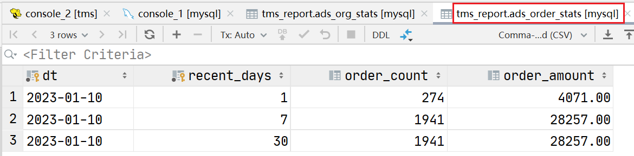

11.2.4 编写导出脚本

1）在hadoop102的/home/atguigu/bin目录下创建hdfs_to_mysql.sh

[atguigu@hadoop102 bin]$ vim hdfs_to_mysql.sh

2）编写如下内容

#!/bin/bash

DATAX_HOME=/opt/module/datax

#DataX导出路径不允许存在空文件，该函数作用为清理空文件

handle_export_path() {

for i in $(hadoop fs -ls -R "$1" | awk '{print $8}'); do

if hadoop fs -test -z "$i"; then

echo "$i文件大小为0，正在删除"

hadoop fs -rm -r -f "$i"

fi

done

}

#数据导出

export_data() {

datax_config=$1

export_dir=$2

handle_export_path "$export_dir"

$DATAX_HOME/bin/datax.py -p"-Dexportdir=$export_dir" "$datax_config"

}

case $1 in

'ads_mileage_stat_last_month' | 'ads_alarm_stat_last_month' | 'ads_temperature_stat_last_month' | 'ads_electric_stat_last_month' | 'ads_consume_stat_last_month')

export_data "/opt/module/datax/job/export/car_data_report.$1.json" "/warehouse/car_data/ads/$1"

;;

'all')

for table in 'ads_mileage_stat_last_month' 'ads_alarm_stat_last_month' 'ads_temperature_stat_last_month' 'ads_electric_stat_last_month' 'ads_consume_stat_last_month'; do

export_data "/opt/module/datax/job/export/car_data_report.$table.json" "/warehouse/car_data/ads/$table"

done

;;

esac

3）增加脚本执行权限

[atguigu@hadoop102 bin]$ chmod +x hdfs_to_mysql.sh

4）脚本用法

[atguigu@hadoop102 bin]$ hdfs_to_mysql.sh all

# 第12章 数据仓库工作流调度

## 12.1 调度工具部署



## 12.2 新数据生成

**1）启动日志采集通道，包括Kafka、Flume等**

**（1）启动Zookeeper**

[atguigu@hadoop102 ~]$ zk.sh start

**（2）启动Kafka**

[atguigu@hadoop102 ~]$ kf.sh start

**（3）启动Flume**

[atguigu@hadoop102 ~]$ f1.sh start

[atguigu@hadoop102 ~]$ f2.sh start

**2）执行日志生成脚本**

[atguigu@hadoop102 ~]$ lg.sh 2023-05-03

**4）观察HDFS上是否有2023-05-03的日志数据生成**

## 12.3 工作流调度实操

由于DolphinScheduler集群模式启动进程较多，对虚拟机内存要求较高。故下面提供两种方式，可根据虚拟机内存情况进行选择。

### 12.3.1 DolphinScheduler集群模式

**1）启动DolphinScheduler**

[atguigu@hadoop102 dolphinscheduler]$ bin/start-all.sh

**2）使用普通用户登录**

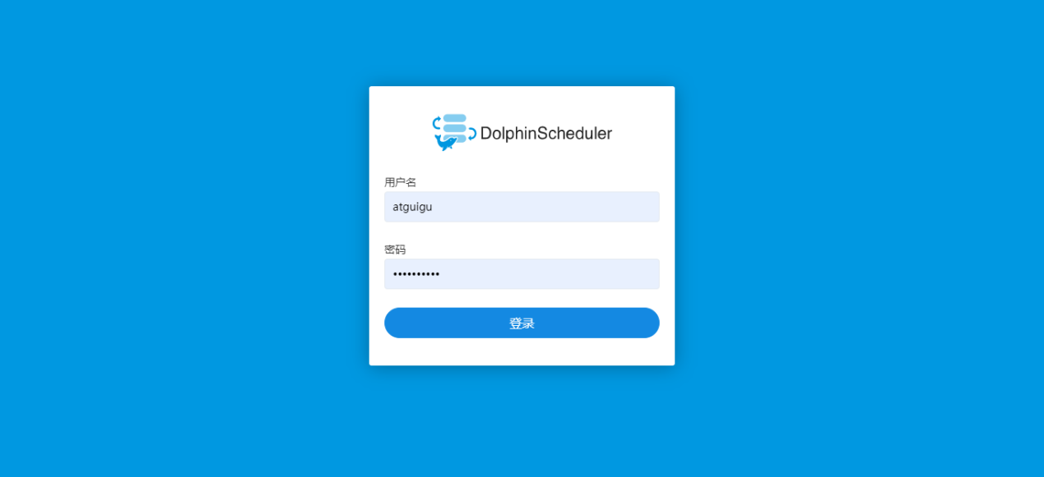

**3）向DolphinScheduler资源中心上传工作流所需脚本**

**（1）创建文件夹**

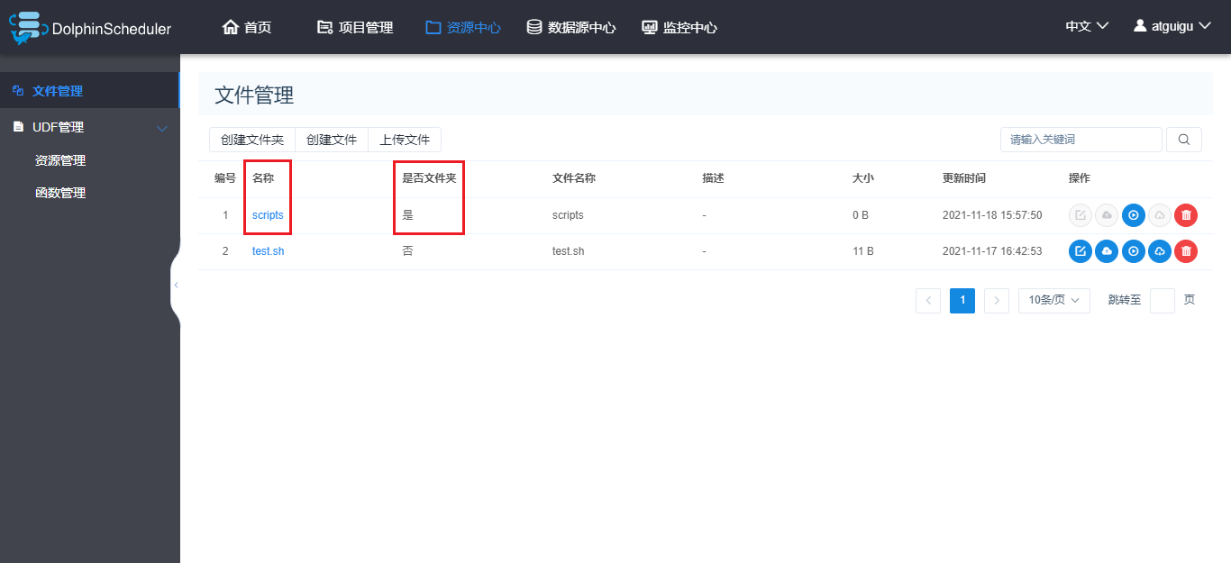

**（2）上传工作流所需脚本**

将工作流所需的所有脚本上传到资源中心scripts路径下，结果如下

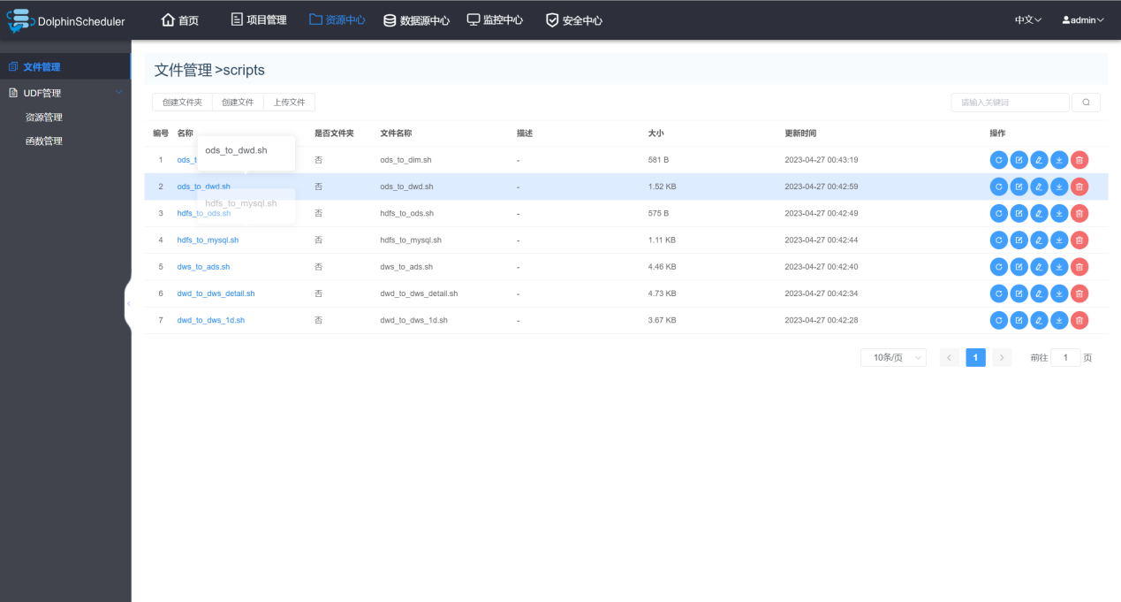

**4）向DolphinScheduler的WorkerServer节点分发脚本依赖的组件**

由于工作流要执行的脚本需要调用Hive、DataX等组件，故在DolphinScheduler的集群模式下，需要确保每个WorkerServer节点都有脚本所依赖的组件。

[atguigu@hadoop102 ~]$ xsync /opt/module/hive/

[atguigu@hadoop102 ~]$ xsync /opt/module/spark/

[atguigu@hadoop102 ~]$ xsync /opt/module/datax/

**5）创建所需环境**

**（1）切换到admin用户**

**（2）点击环境管理/创建环境**

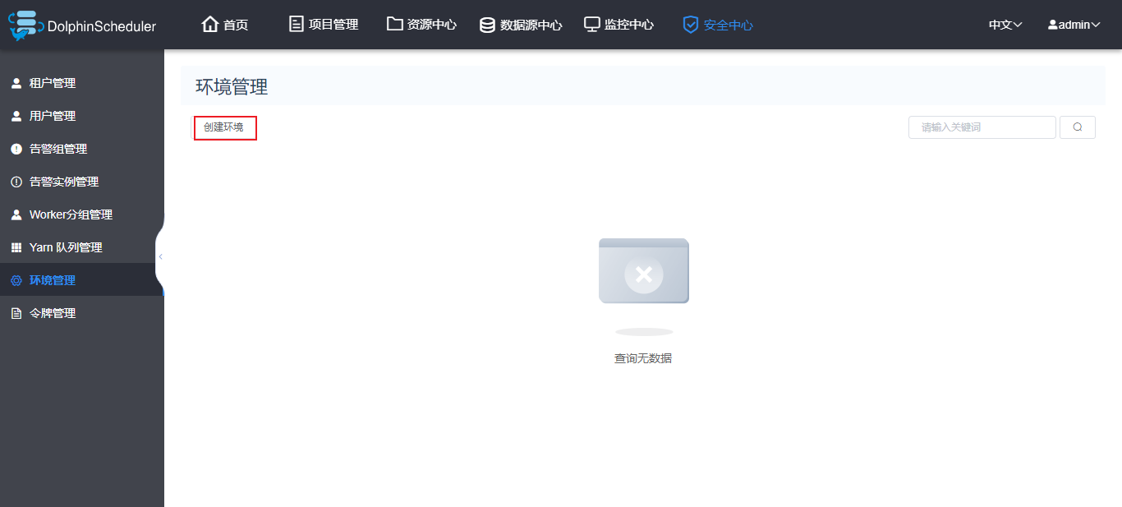

**（3）配置环境**

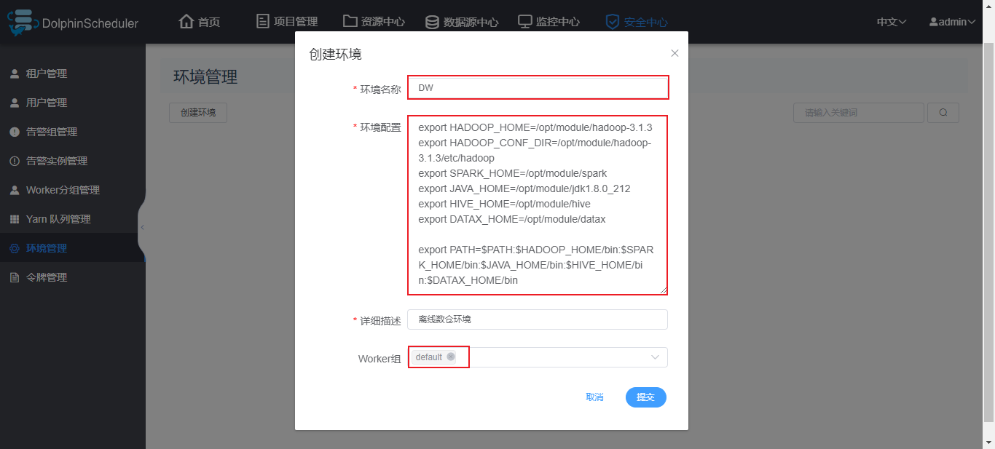

**注：具体环境变量如下**

export HADOOP_HOME=/opt/module/hadoop

export HADOOP_CONF_DIR=/opt/module/hadoop/etc/hadoop

export SPARK_HOME=/opt/module/spark

export JAVA_HOME=/opt/module/jdk1.8.0_212

export HIVE_HOME=/opt/module/hive

export DATAX_HOME=/opt/module/datax

export PATH=$PATH:$HADOOP_HOME/bin:$SPARK_HOME/bin:$JAVA_HOME/bin:$HIVE_HOME/bin:$DATAX_HOME/bin

**6）创建工作流**

**（0）切换到普通用户**

**（1）在car_data项目下创建工作流**

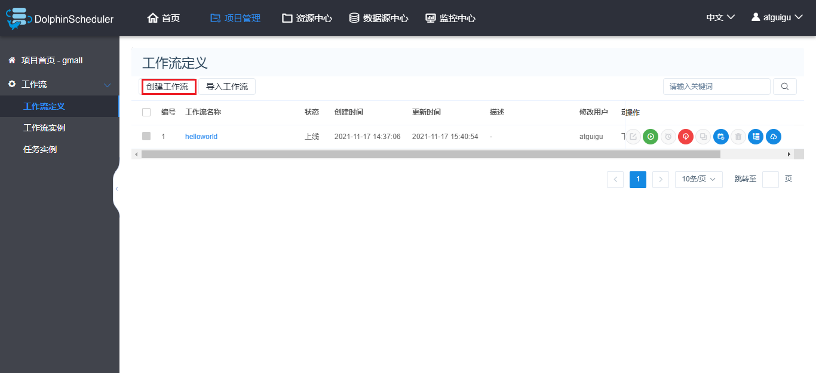

**（2）各任务节点配置如下**

mysql_to_hdfs

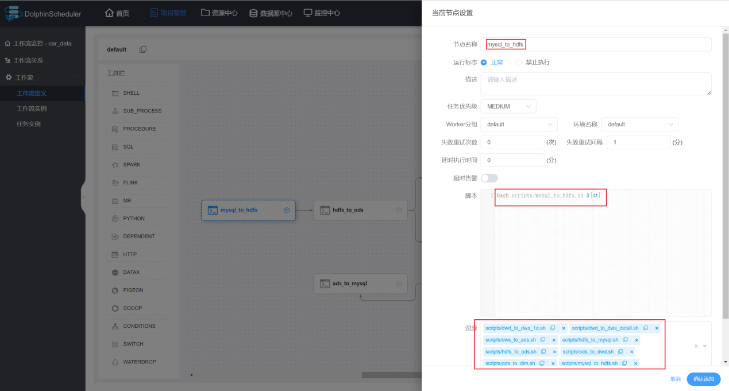

hdfs_to_ods

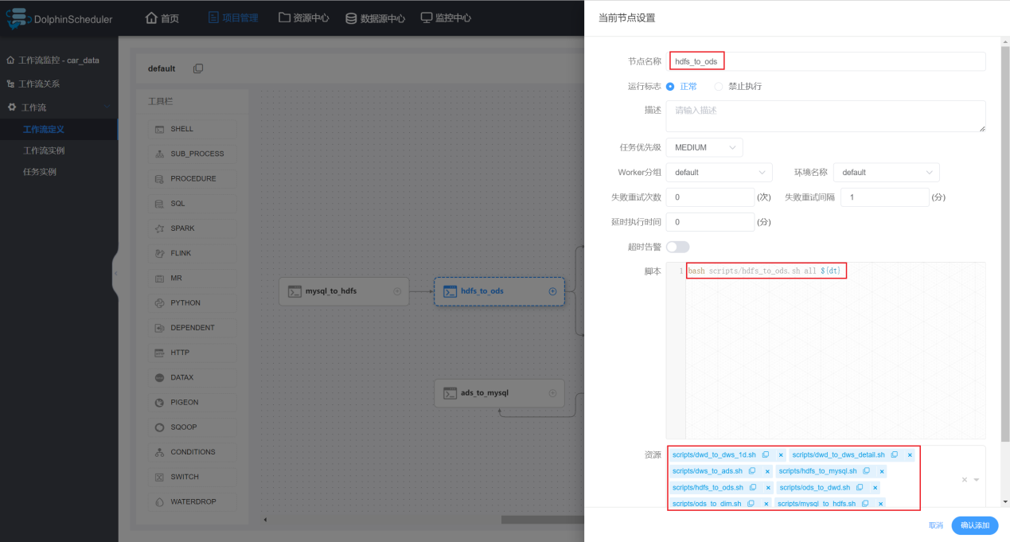

ods_to_dwd

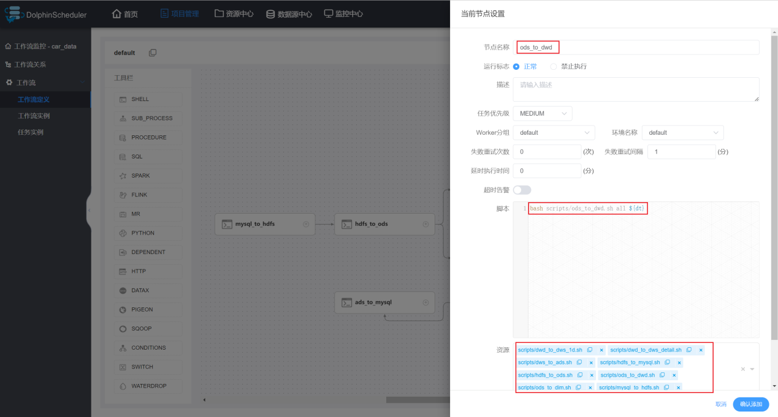

ods_to_dim

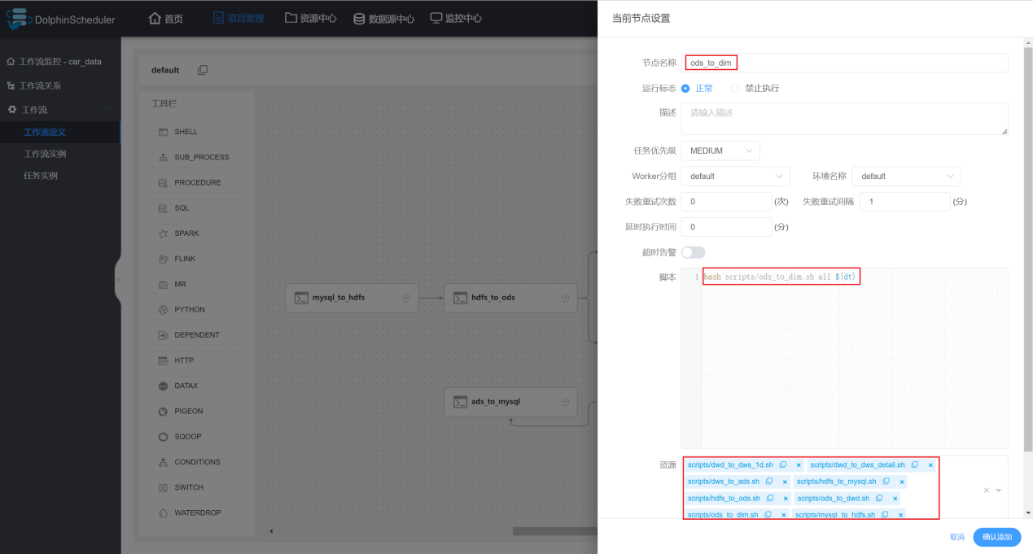

dwd_to_dws_detail

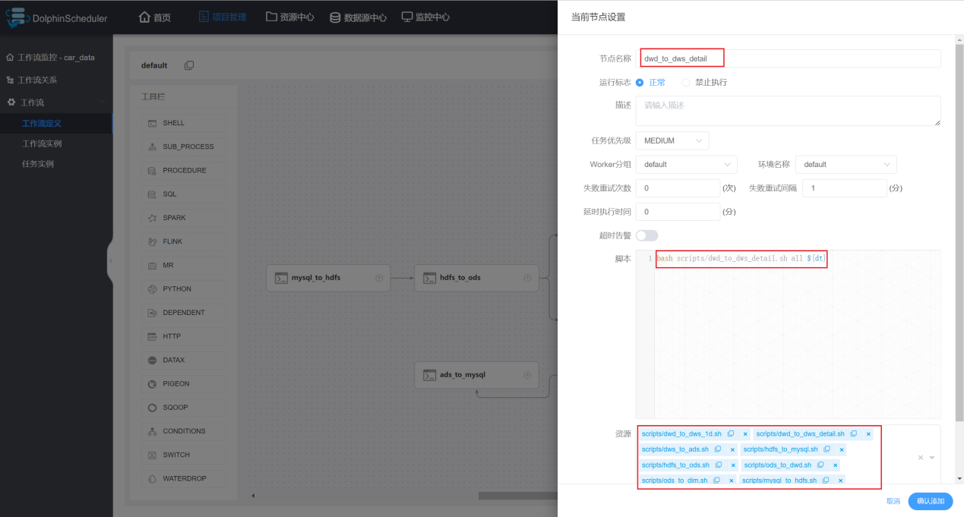

dwd_to_dws_1d

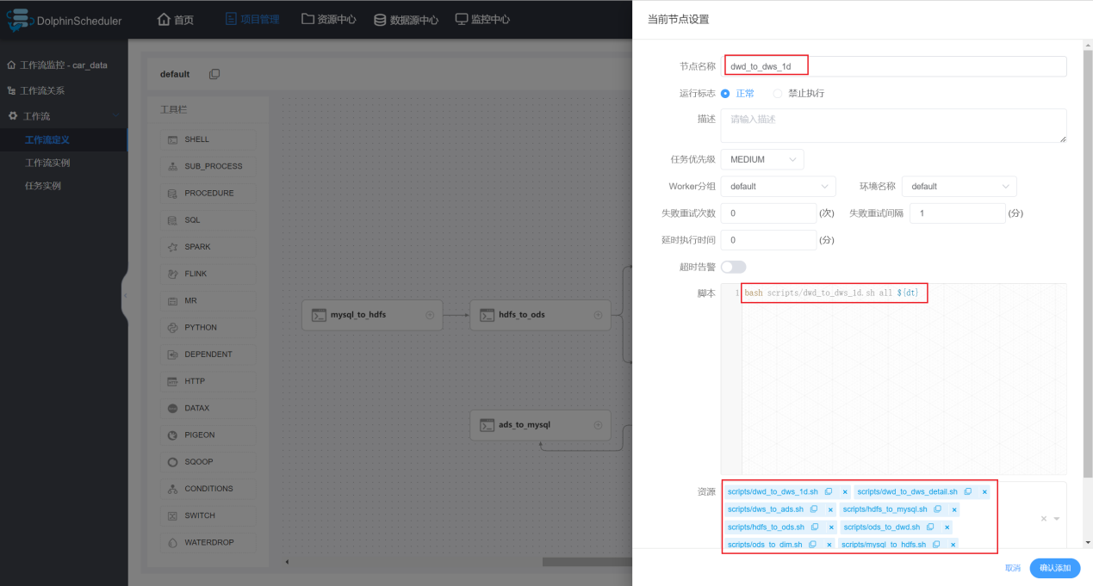

dws_to_ads

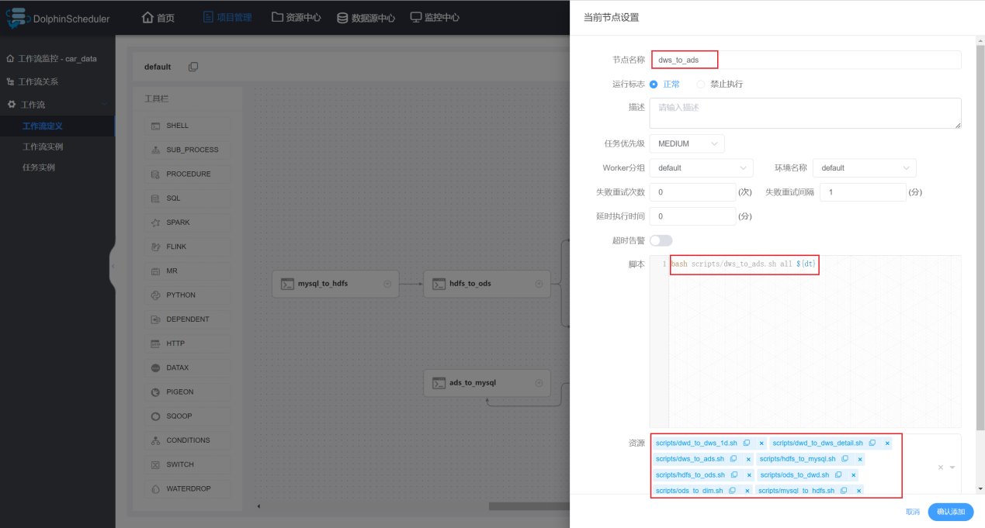

ads_to_mysql

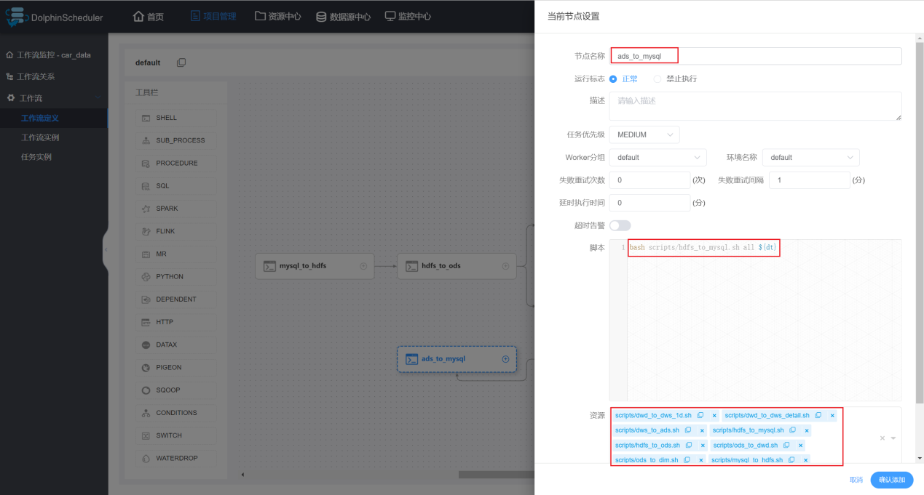

**（3）各节点依赖关系如下**

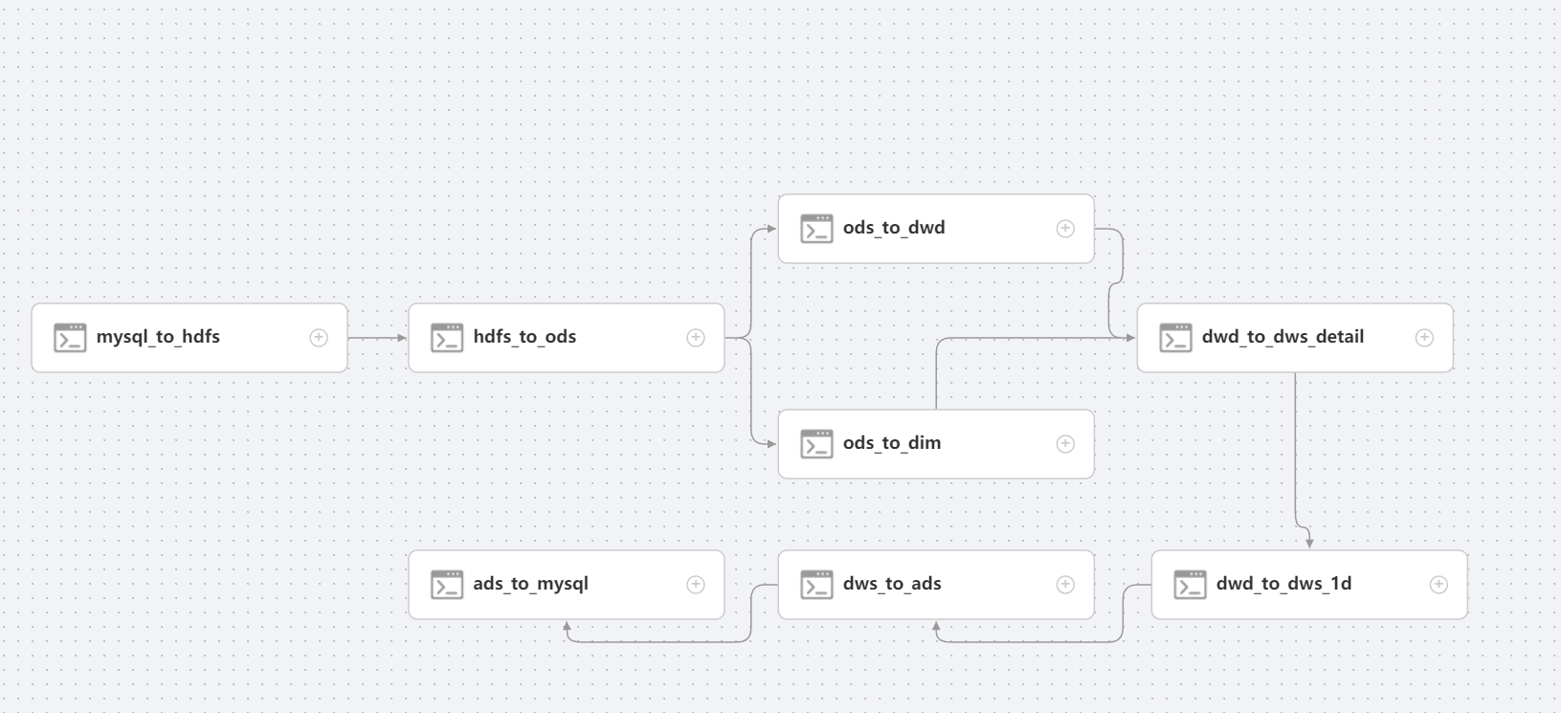

**（4）保存工作流**

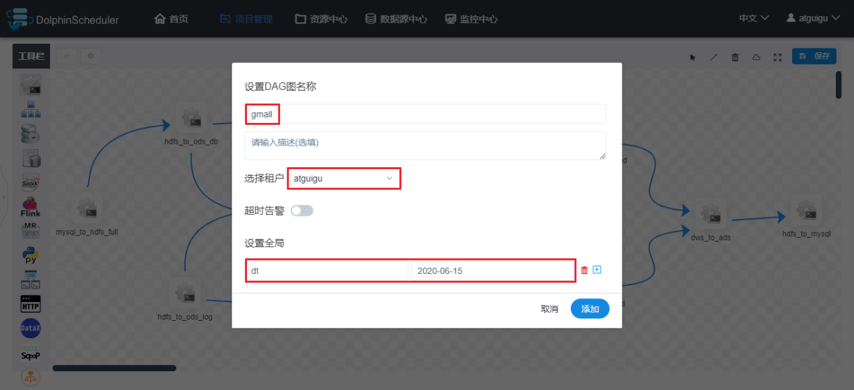

**注：定时调度时，全局参数值应设置为$[yyyy-MM-dd-1]或者空值。**

**7）上线工作流**

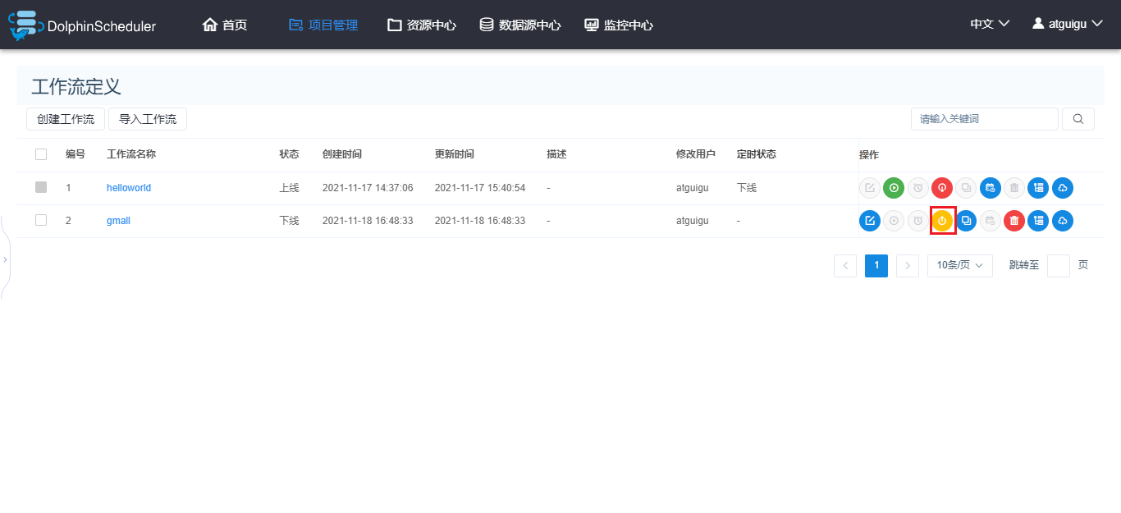

**8）执行工作流**

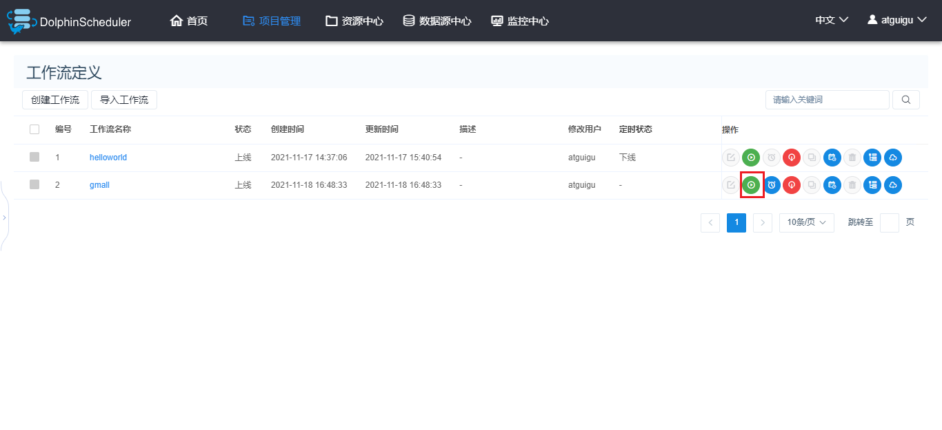

### 12.3.2 DolphinScheduler单机模式

**1）启动DolphinScheduler**

[atguigu@hadoop102 dolphinscheduler]$ bin/dolphinscheduler-daemon.sh start standalone-server

**2）其余操作**

其余操作与集群模式基本一致，其中分发Hive、Spark、DataX这一步可以省略。